UNITED STATES
SECURITIES AND EXCHANGE COMMISSION
WASHINGTON, D.C. 20549

FORM 8-K

CURRENT REPORT
Pursuant to Section 13 or 15(d) of the Securities Exchange Act of 1934
Date of Report (Date of earliest event reported): May 15, 2026

UNITIL CORPORATION
(Exact name of Registrant as Specified in Its Charter)

New Hampshire |  |  | 1-8858 | 02-0381573
(State or Other Jurisdiction  of Incorporation) |  |  | (Commission File Number) | (IRS Employer  Identification No.)
6 Liberty Lane West
Hampton, New Hampshire |  |  |  | 03842-1720
(Address of Principal Executive Offices) |  |  |  | (Zip Code)

Registrant’s Telephone Number, Including Area Code: (603) 772-0775

N/A
(Former Name or Former Address, if Changed Since Last Report)

Check the appropriate box below if the Form 8-K filing is intended to simultaneously satisfy the filing obligation of the registrant under any of the following provisions:
☐Written communications pursuant to Rule 425 under the Securities Act (17 CFR 230.425)
☐Soliciting material pursuant to Rule 14a-12 under the Exchange Act (17 CFR 240.14a-12)
☐Pre-commencement communications pursuant to Rule 14d-2(b) under the Exchange Act (17 CFR 240.14d-2(b))
☐Pre-commencement communications pursuant to Rule 13e-4(c) under the Exchange Act (17 CFR 240.13e-4(c))
Securities registered pursuant to Section 12(b) of the Act:
Title of each class |  | Trading  Symbol(s) |  | Name of each exchange on which registered
Common Stock, no par value |  | UTL |  | The New York Stock Exchange
Indicate by check mark whether the registrant is an emerging growth company as defined in Rule 405 of the Securities Act of 1933 (§ 230.405 of this chapter) or Rule 12b-2 of the Securities Exchange Act of 1934 (§ 240.12b-2 of this chapter).
Emerging growth company ☐
If an emerging growth company, indicate by check mark if the registrant has elected not to use the extended transition period for complying with any new or revised financial accounting standards provided pursuant to Section 13(a) of the Exchange Act. ☐

Item 7.01 Regulation FD Disclosure.
From May 17, 2026 through May 19, 2026, Unitil Corporation will attend the American Gas Association (“AGA”) Financial Forum. Today, the Company posted a presentation to the investor relations section of the Company’s website (www.unitil.com/investors) that may be discussed during the AGA Financial Forum. That presentation is attached as Exhibit 99.1.

Item 9.01 Financial Statements and Exhibits.
(d) Exhibits

Number | Exhibit
99.1 | Unitil Corporation's presentation to attendees at the American Gas Association's Financial Forum
104 | Cover Page Interactive Data File (embedded within the Inline XBRL document)

SIGNATURES
Pursuant to the requirements of the Securities Exchange Act of 1934, the registrant has duly caused this report to be signed on its behalf by the undersigned hereunto duly authorized.
 |  |  | UNITIL CORPORATION
Date: | May 15, 2026 | By: | /s/ Daniel J. Hurstak
Daniel J. Hurstak
Senior Vice President, Chief Financial Officer and Treasurer

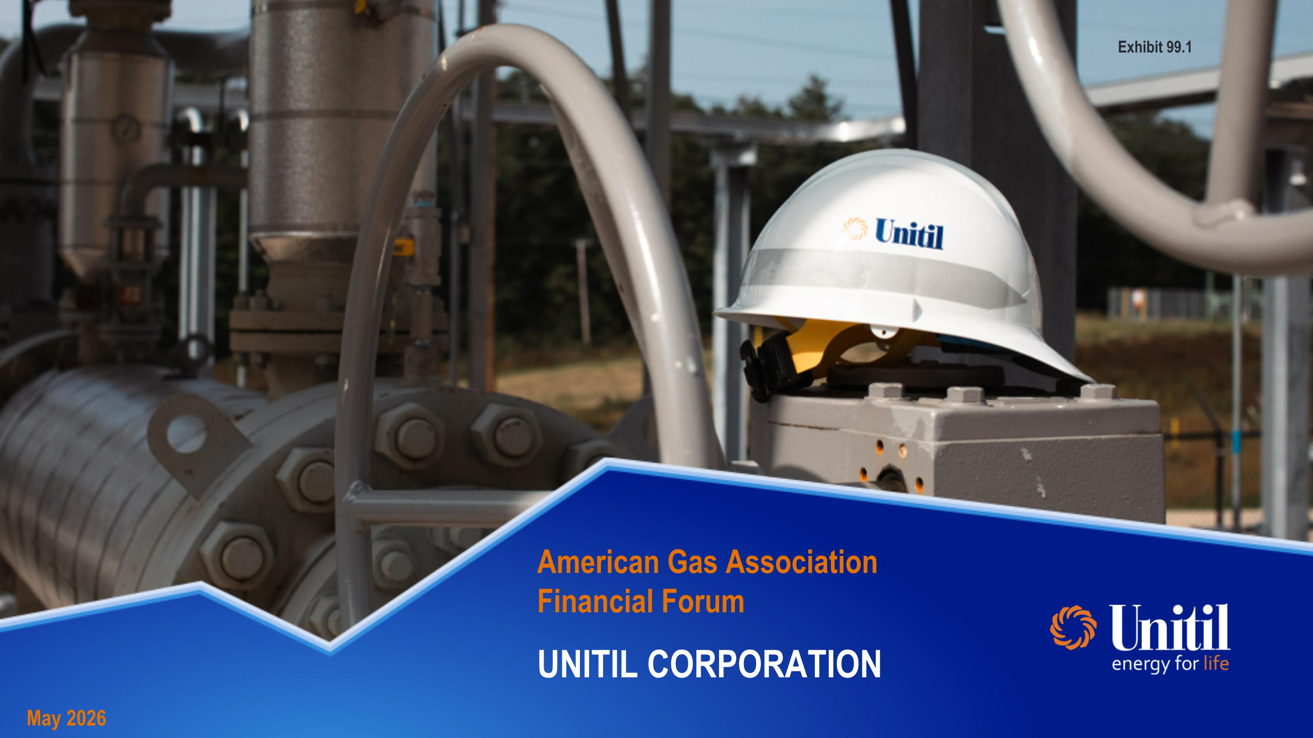
American Gas Association?Financial Forum May 2026 UNITIL CORPORATION Exhibit 99.1

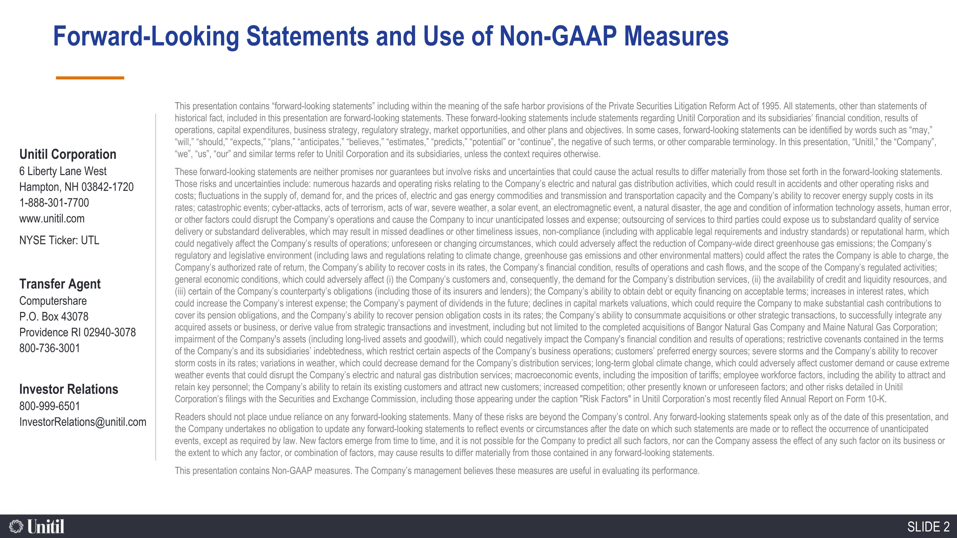
Forward-Looking Statements and Use of Non-GAAP Measures Unitil Corporation 6 Liberty Lane West Hampton, NH 03842-1720 1-888-301-7700 www.unitil.com NYSE Ticker: UTL Transfer Agent Computershare P.O. Box 43078 Providence RI 02940-3078 800-736-3001 Investor Relations 800-999-6501 InvestorRelations@unitil.com This presentation contains “forward-looking statements” including within the meaning of the safe harbor provisions of the Private Securities Litigation Reform Act of 1995. All statements, other than statements of historical fact, included in this presentation are forward-looking statements. These forward-looking statements include statements regarding Unitil Corporation and its subsidiaries’ financial condition, results of operations, capital expenditures, business strategy, regulatory strategy, market opportunities, and other plans and objectives. In some cases, forward-looking statements can be identified by words such as “may,” “will,” “should,” “expects,” “plans,” “anticipates,” “believes,” “estimates,” “predicts,” “potential” or “continue”, the negative of such terms, or other comparable terminology. In this presentation, “Unitil,” the “Company”, “we”, “us”, “our” and similar terms refer to Unitil Corporation and its subsidiaries, unless the context requires otherwise. These forward-looking statements are neither promises nor guarantees but involve risks and uncertainties that could cause the actual results to differ materially from those set forth in the forward-looking statements. Those risks and uncertainties include: numerous hazards and operating risks relating to the Company’s electric and natural gas distribution activities, which could result in accidents and other operating risks and costs; fluctuations in the supply of, demand for, and the prices of, electric and gas energy commodities and transmission and transportation capacity and the Company’s ability to recover energy supply costs in its rates; catastrophic events; cyber-attacks, acts of terrorism, acts of war, severe weather, a solar event, an electromagnetic event, a natural disaster, the age and condition of information technology assets, human error, or other factors could disrupt the Company’s operations and cause the Company to incur unanticipated losses and expense; outsourcing of services to third parties could expose us to substandard quality of service delivery or substandard deliverables, which may result in missed deadlines or other timeliness issues, non-compliance (including with applicable legal requirements and industry standards) or reputational harm, which could negatively affect the Company’s results of operations; unforeseen or changing circumstances, which could adversely affect the reduction of Company-wide direct greenhouse gas emissions; the Company’s regulatory and legislative environment (including laws and regulations relating to climate change, greenhouse gas emissions and other environmental matters) could affect the rates the Company is able to charge, the Company’s authorized rate of return, the Company’s ability to recover costs in its rates, the Company’s financial condition, results of operations and cash flows, and the scope of the Company’s regulated activities; general economic conditions, which could adversely affect (i) the Company’s customers and, consequently, the demand for the Company’s distribution services, (ii) the availability of credit and liquidity resources, and (iii) certain of the Company’s counterparty’s obligations (including those of its insurers and lenders); the Company’s ability to obtain debt or equity financing on acceptable terms; increases in interest rates, which could increase the Company’s interest expense; the Company’s payment of dividends in the future; declines in capital markets valuations, which could require the Company to make substantial cash contributions to cover its pension obligations, and the Company’s ability to recover pension obligation costs in its rates; the Company’s ability to consummate acquisitions or other strategic transactions, to successfully integrate any acquired assets or business, or derive value from strategic transactions and investment, including but not limited to the completed acquisitions of Bangor Natural Gas Company and Maine Natural Gas Corporation; impairment of the Company's assets (including long-lived assets and goodwill), which could negatively impact the Company's financial condition and results of operations; restrictive covenants contained in the terms of the Company’s and its subsidiaries’ indebtedness, which restrict certain aspects of the Company’s business operations; customers’ preferred energy sources; severe storms and the Company’s ability to recover storm costs in its rates; variations in weather, which could decrease demand for the Company’s distribution services; long-term global climate change, which could adversely affect customer demand or cause extreme weather events that could disrupt the Company’s electric and natural gas distribution services; macroeconomic events, including the imposition of tariffs; employee workforce factors, including the ability to attract and retain key personnel; the Company’s ability to retain its existing customers and attract new customers; increased competition; other presently known or unforeseen factors; and other risks detailed in Unitil Corporation’s filings with the Securities and Exchange Commission, including those appearing under the caption "Risk Factors" in Unitil Corporation’s most recently filed Annual Report on Form 10-K. Readers should not place undue reliance on any forward-looking statements. Many of these risks are beyond the Company’s control. Any forward-looking statements speak only as of the date of this presentation, and the Company undertakes no obligation to update any forward-looking statements to reflect events or circumstances after the date on which such statements are made or to reflect the occurrence of unanticipated events, except as required by law. New factors emerge from time to time, and it is not possible for the Company to predict all such factors, nor can the Company assess the effect of any such factor on its business or the extent to which any factor, or combination of factors, may cause results to differ materially from those contained in any forward-looking statements. This presentation contains Non-GAAP measures. The Company’s management believes these measures are useful in evaluating its performance.

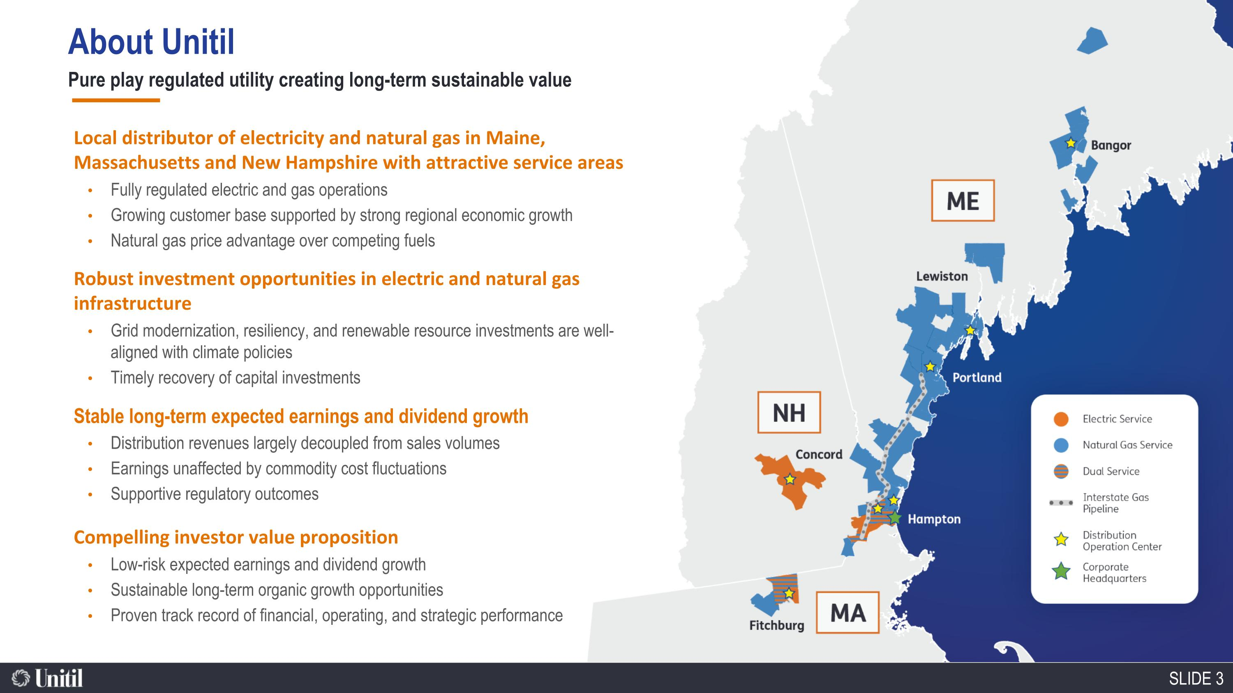
110,100 Electric Customers 105,000 Natural Gas Customers Local distributor of electricity and natural gas in Maine, Massachusetts and New Hampshire with attractive service areas Fully regulated electric and gas operations Growing customer base supported by strong regional economic growth Natural gas price advantage over competing fuels Robust investment opportunities in electric and natural gas infrastructure Grid modernization, resiliency, and renewable resource investments are well-aligned with climate policies Timely recovery of capital investments Stable long-term expected earnings and dividend growth Distribution revenues largely decoupled from sales volumes Earnings unaffected by commodity cost fluctuations Supportive regulatory outcomes Compelling investor value proposition Low-risk expected earnings and dividend growth Sustainable long-term organic growth opportunities Proven track record of financial, operating, and strategic performance About Unitil Pure play regulated utility creating long-term sustainable value

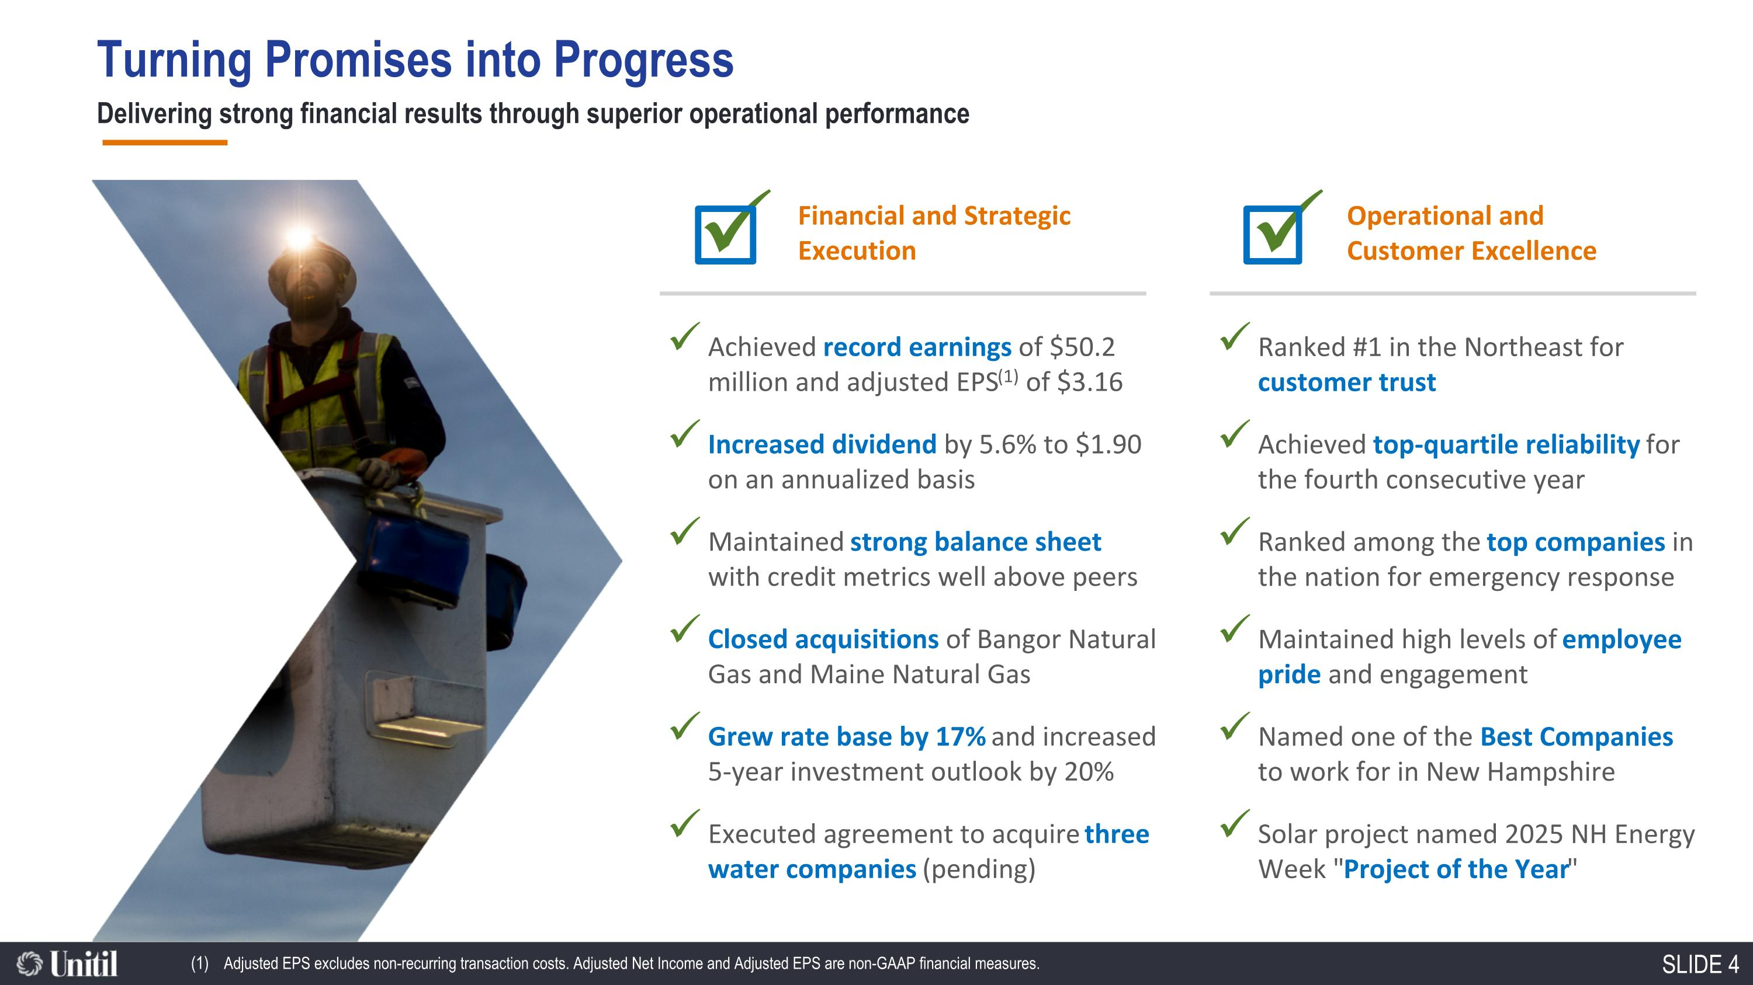
Turning Promises into Progress Delivering strong financial results through superior operational performance ü Financial and Strategic Execution Achieved record earnings of $50.2 million and adjusted EPS(1) of $3.16 Increased dividend by 5.6% to $1.90 on an annualized basis Maintained strong balance sheet with credit metrics well above peers Closed acquisitions of Bangor Natural Gas and Maine Natural Gas Grew rate base by 17% and increased 5-year investment outlook by 20% Executed agreement to acquire three water companies (pending) Ranked #1 in the Northeast for customer trust Achieved top-quartile reliability for the fourth consecutive year Ranked among the top companies in the nation for emergency response Maintained high levels of employee pride and engagement Named one of the Best Companies to work for in New Hampshire Solar project named 2025 NH Energy Week "Project of the Year" ü Operational and Customer Excellence Adjusted EPS excludes non-recurring transaction costs. Adjusted Net Income and Adjusted EPS are non-GAAP financial measures.

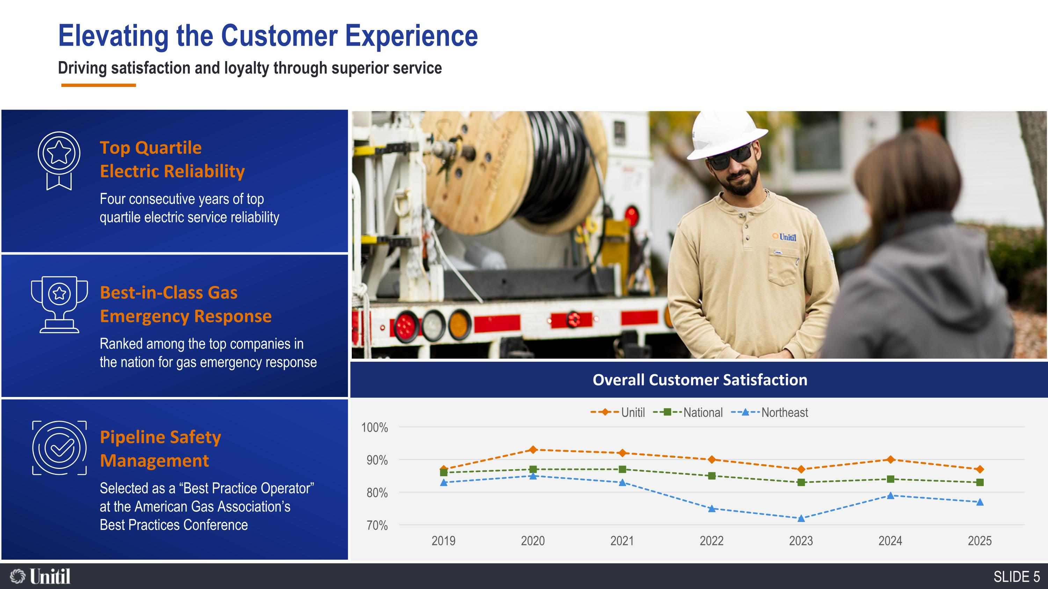
Overall Customer Satisfaction Top Quartile Electric Reliability Four consecutive years of top quartile electric service reliability Best-in-Class Gas Emergency Response Ranked among the top companies in the nation for gas emergency response Pipeline Safety Management Selected as a “Best Practice Operator” at the American Gas Association’s Best Practices Conference Elevating the Customer Experience Driving satisfaction and loyalty through superior service

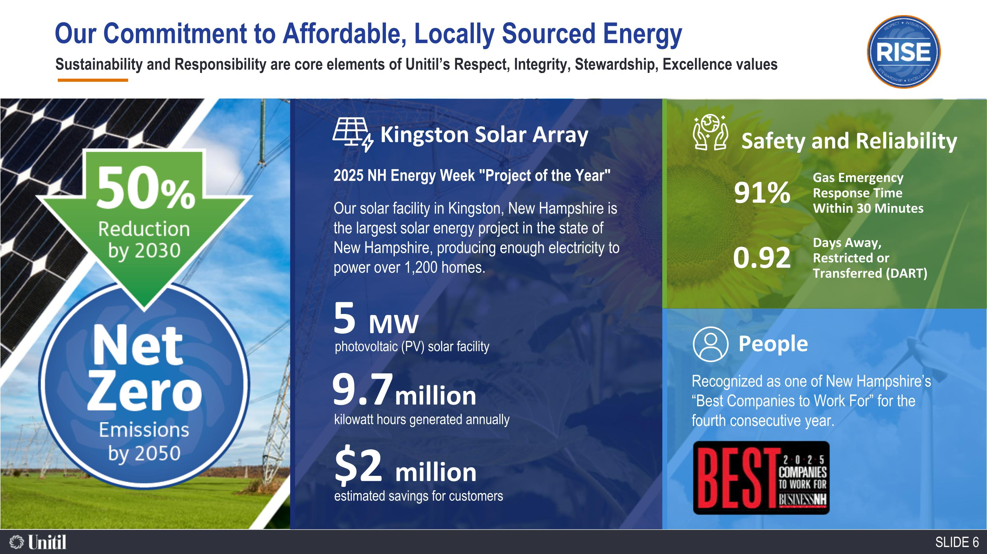
Sustainability and Responsibility are core elements of Unitil’s Respect, Integrity, Stewardship, Excellence values Recognized as one of New Hampshire’s “Best Companies to Work For” for the fourth consecutive year. People 2025 NH Energy Week "Project of the Year" Our solar facility in Kingston, New Hampshire is the largest solar energy project in the state of New Hampshire, producing enough electricity to power over 1,200 homes. Kingston Solar Array 9.7million kilowatt hours generated annually 5 MW photovoltaic (PV) solar facility $2 million estimated savings for customers Safety and Reliability Days Away, Restricted or Transferred (DART) 91% Gas Emergency Response Time Within 30 Minutes 0.92 Our Commitment to Affordable, Locally Sourced Energy

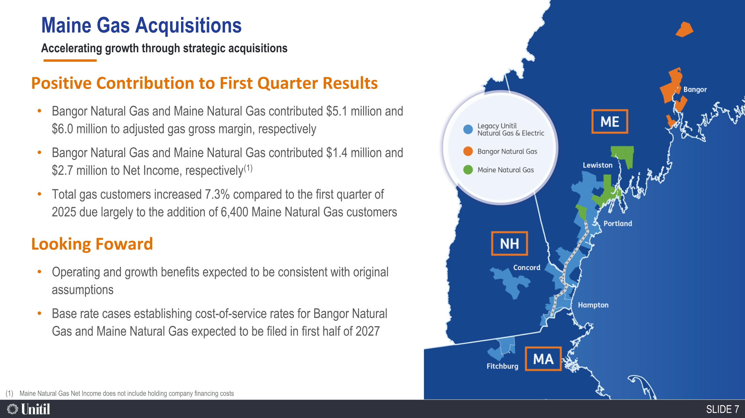
Accelerating growth through strategic acquisitions Looking Foward Operating and growth benefits expected to be consistent with original assumptions Base rate cases establishing cost-of-service rates for Bangor Natural Gas and Maine Natural Gas expected to be filed in first half of 2027 Positive Contribution to First Quarter Results Bangor Natural Gas and Maine Natural Gas contributed $5.1 million and $6.0 million to adjusted gas gross margin, respectively Bangor Natural Gas and Maine Natural Gas contributed $1.4 million and $2.7 million to Net Income, respectively(1) Total gas customers increased 7.3% compared to the first quarter of 2025 due largely to the addition of 6,400 Maine Natural Gas customers Maine Natural Gas Net Income does not include holding company financing costs Maine Gas Acquisitions

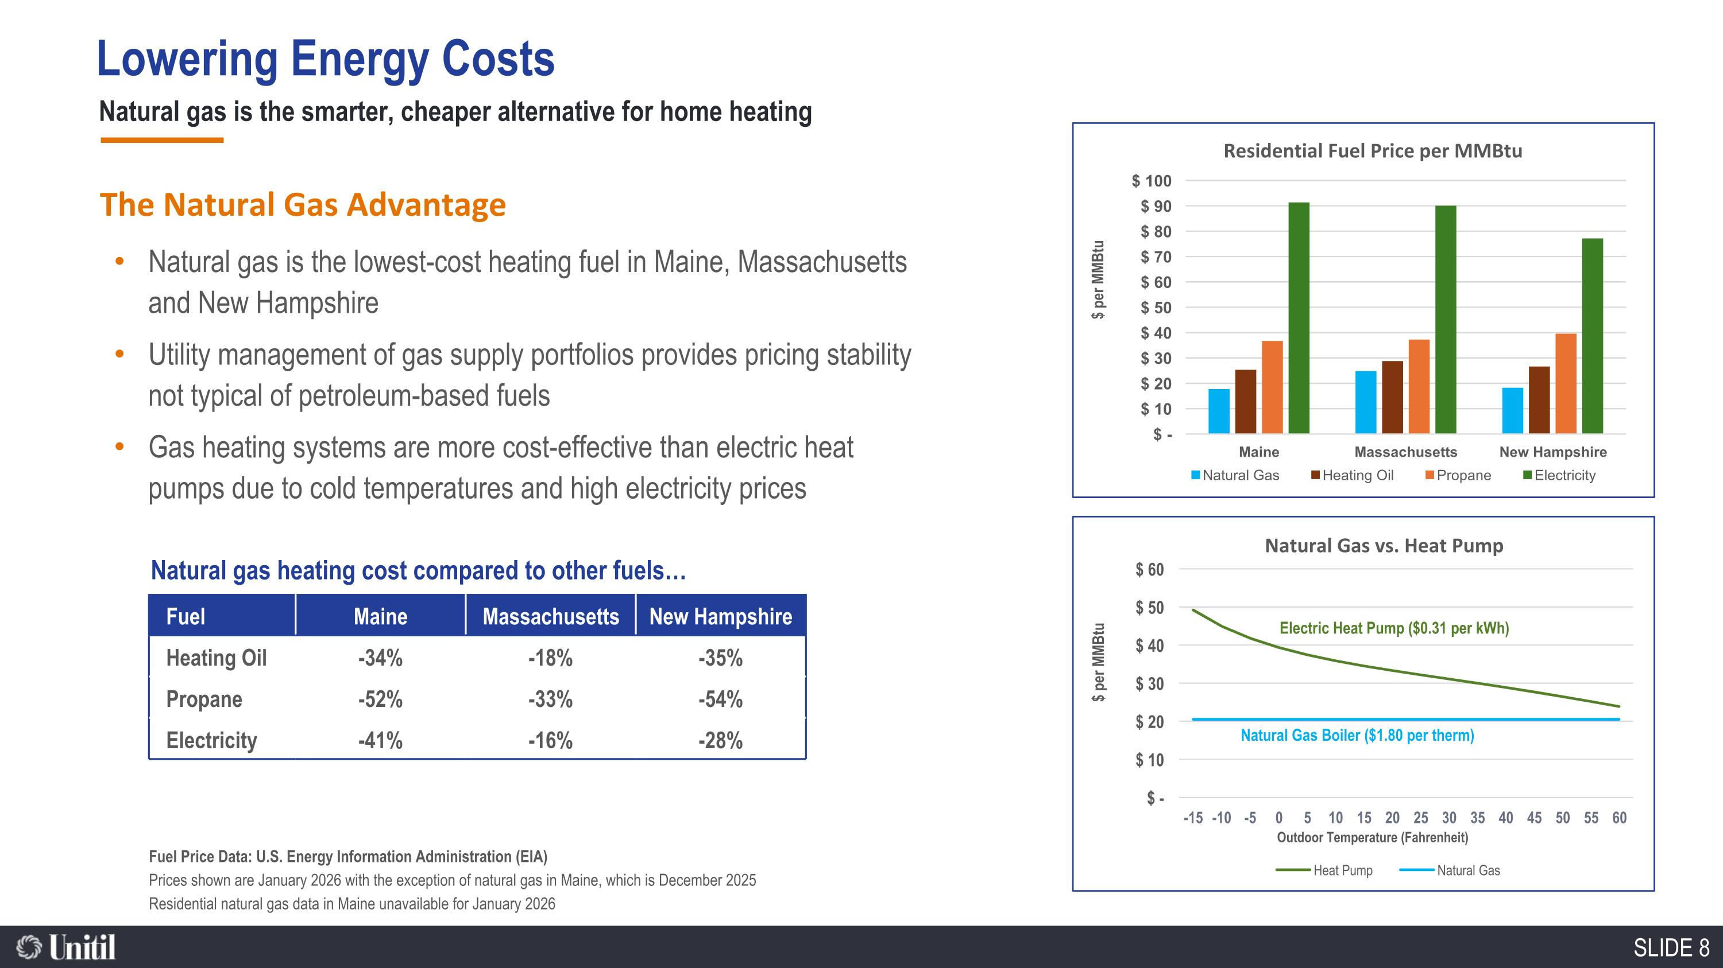
Lowering Energy Costs Natural gas is the smarter, cheaper alternative for home heating Fuel Price Data: U.S. Energy Information Administration (EIA) Prices shown are January 2026 with the exception of natural gas in Maine, which is December 2025 Residential natural gas data in Maine unavailable for January 2026 Natural gas heating cost compared to other fuels Fuel Maine Massachusetts New Hampshire Heating Oil -34% -18% -35% Propane -52% -33% -54% Electricity -41% -16% -28% The Natural Gas Advantage Natural gas is the lowest-cost heating fuel in Maine, Massachusetts and New Hampshire Utility management of gas supply portfolios provides pricing stability not typical of petroleum-based fuels Gas heating systems are more cost-effective than electric heat pumps due to cold temperatures and high electricity prices Electric Heat Pump ($0.31 per kWh) Natural Gas Boiler ($1.80 per therm)

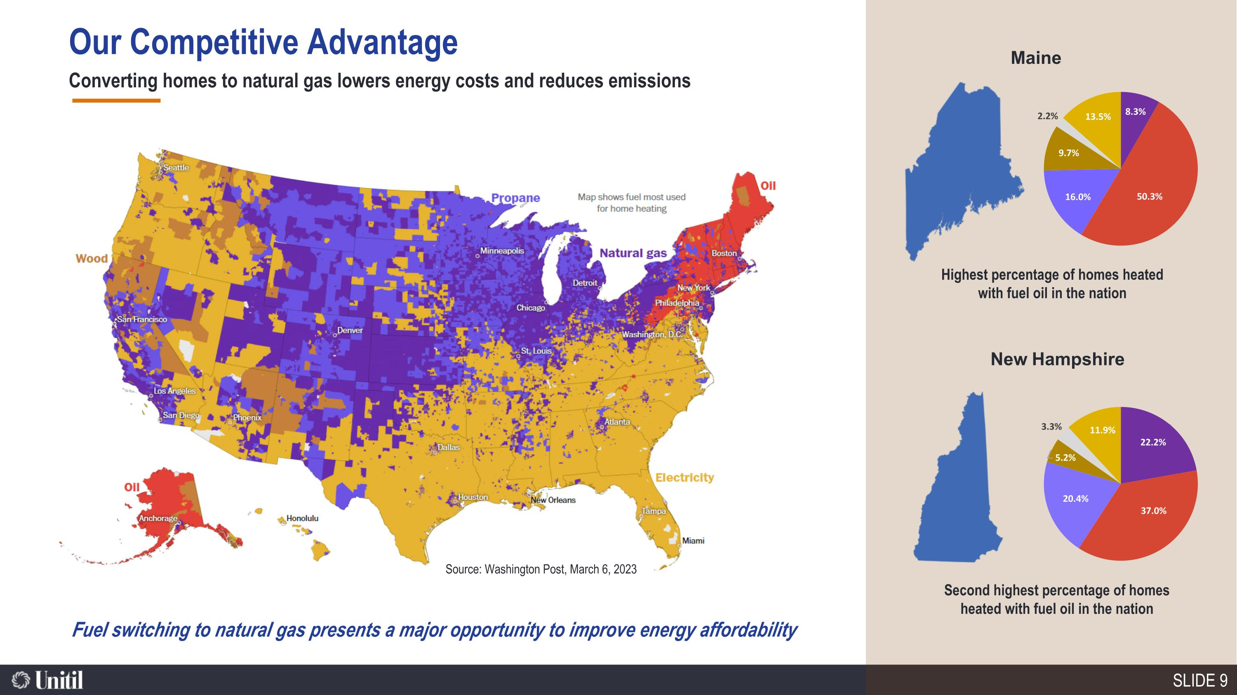
Our Competitive Advantage Maine New Hampshire Highest percentage of homes heated with fuel oil in the nation Second highest percentage of homes heated with fuel oil in the nation Converting homes to natural gas lowers energy costs and reduces emissions Fuel switching to natural gas presents a major opportunity to improve energy affordability Source: Washington Post, March 6, 2023

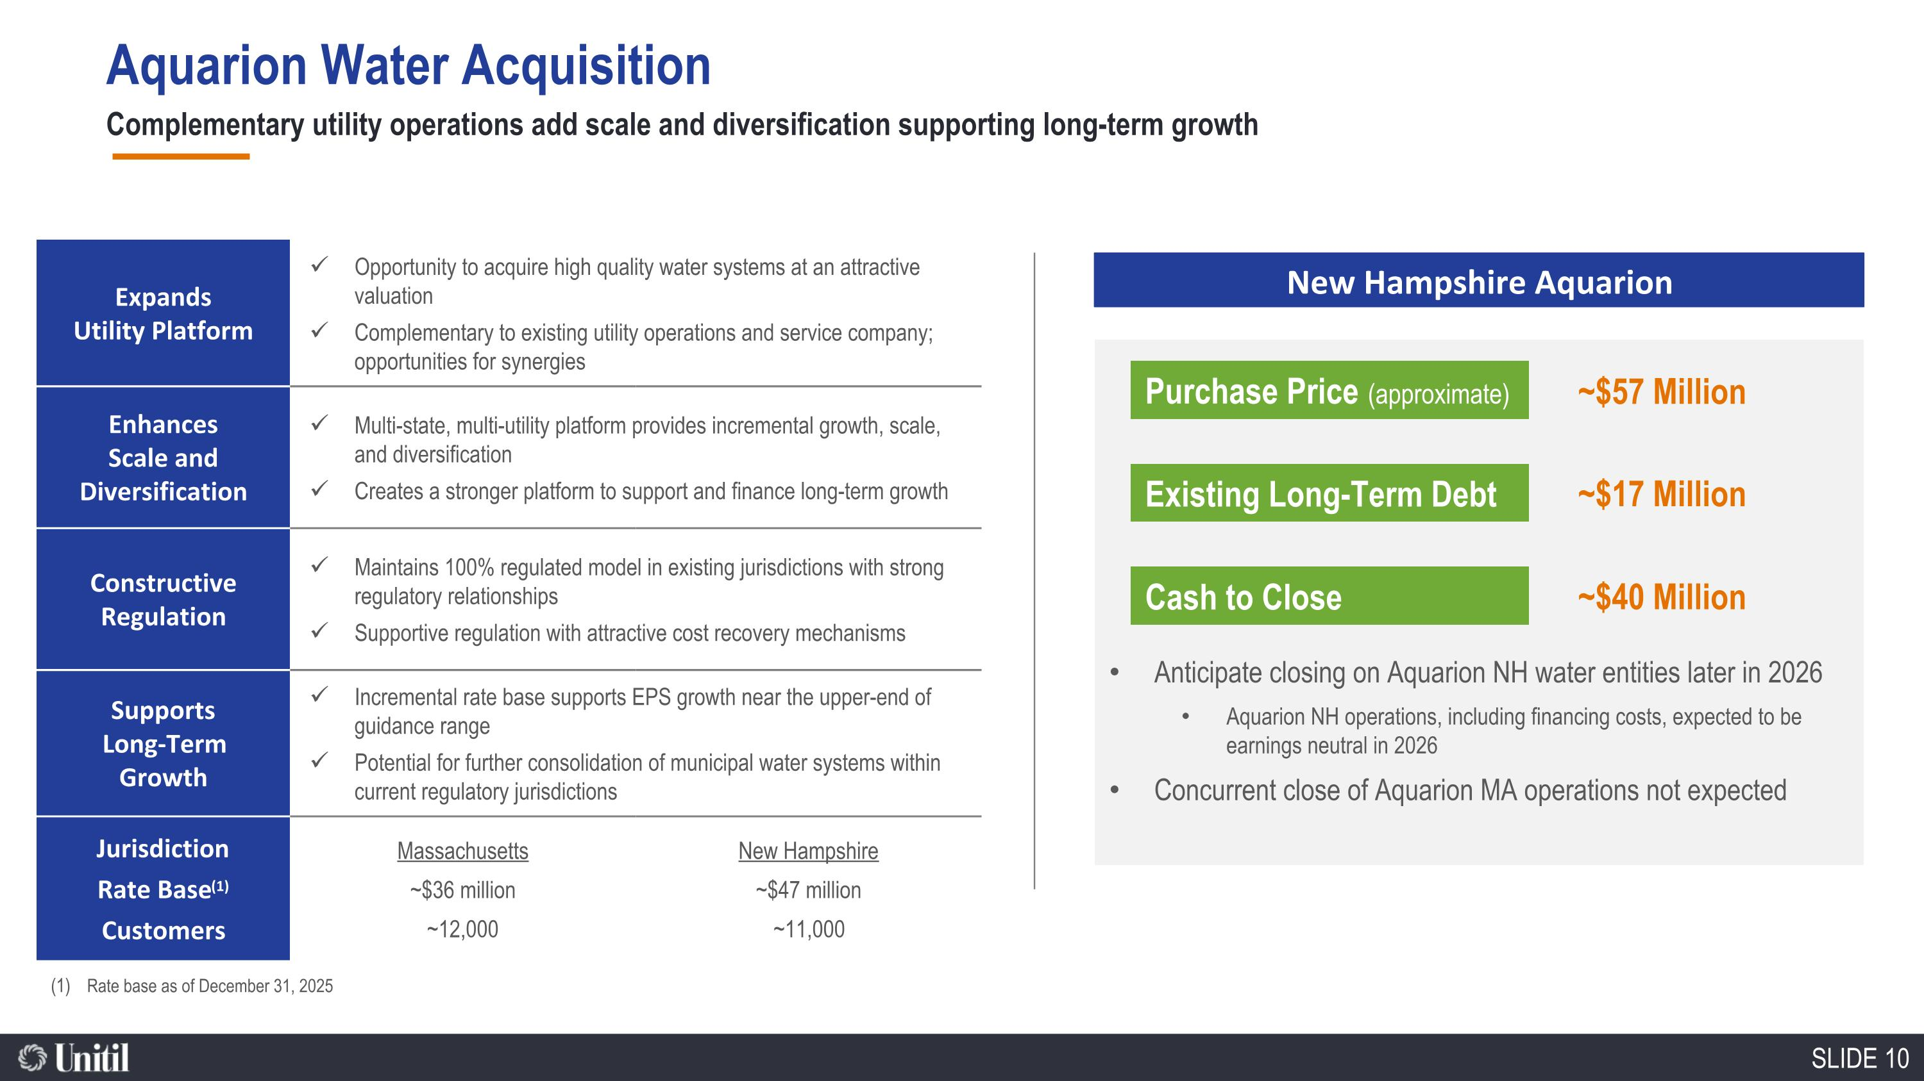
Aquarion Water Acquisition Expands Utility Platform Opportunity to acquire high quality water systems at an attractive valuation Complementary to existing utility operations and service company; opportunities for synergies Enhances Scale and Diversification Multi-state, multi-utility platform provides incremental growth, scale, and diversification Creates a stronger platform to support and finance long-term growth Constructive Regulation Maintains 100% regulated model in existing jurisdictions with strong regulatory relationships Supportive regulation with attractive cost recovery mechanisms Supports Long-Term Growth Incremental rate base supports EPS growth near the upper-end of guidance range Potential for further consolidation of municipal water systems within current regulatory jurisdictions Jurisdiction Massachusetts New Hampshire Rate Base(1) ~$36 million ~$47 million Customers ~12,000 ~11,000 Complementary utility operations add scale and diversification supporting long-term growth Rate base as of December 31, 2025 Purchase Price (approximate) New Hampshire Aquarion ~$57 Million Existing Long-Term Debt ~$17 Million Cash to Close ~$40 Million Anticipate closing on Aquarion NH water entities later in 2026 Aquarion NH operations, including financing costs, expected to be earnings neutral in 2026 Concurrent close of Aquarion MA operations not expected

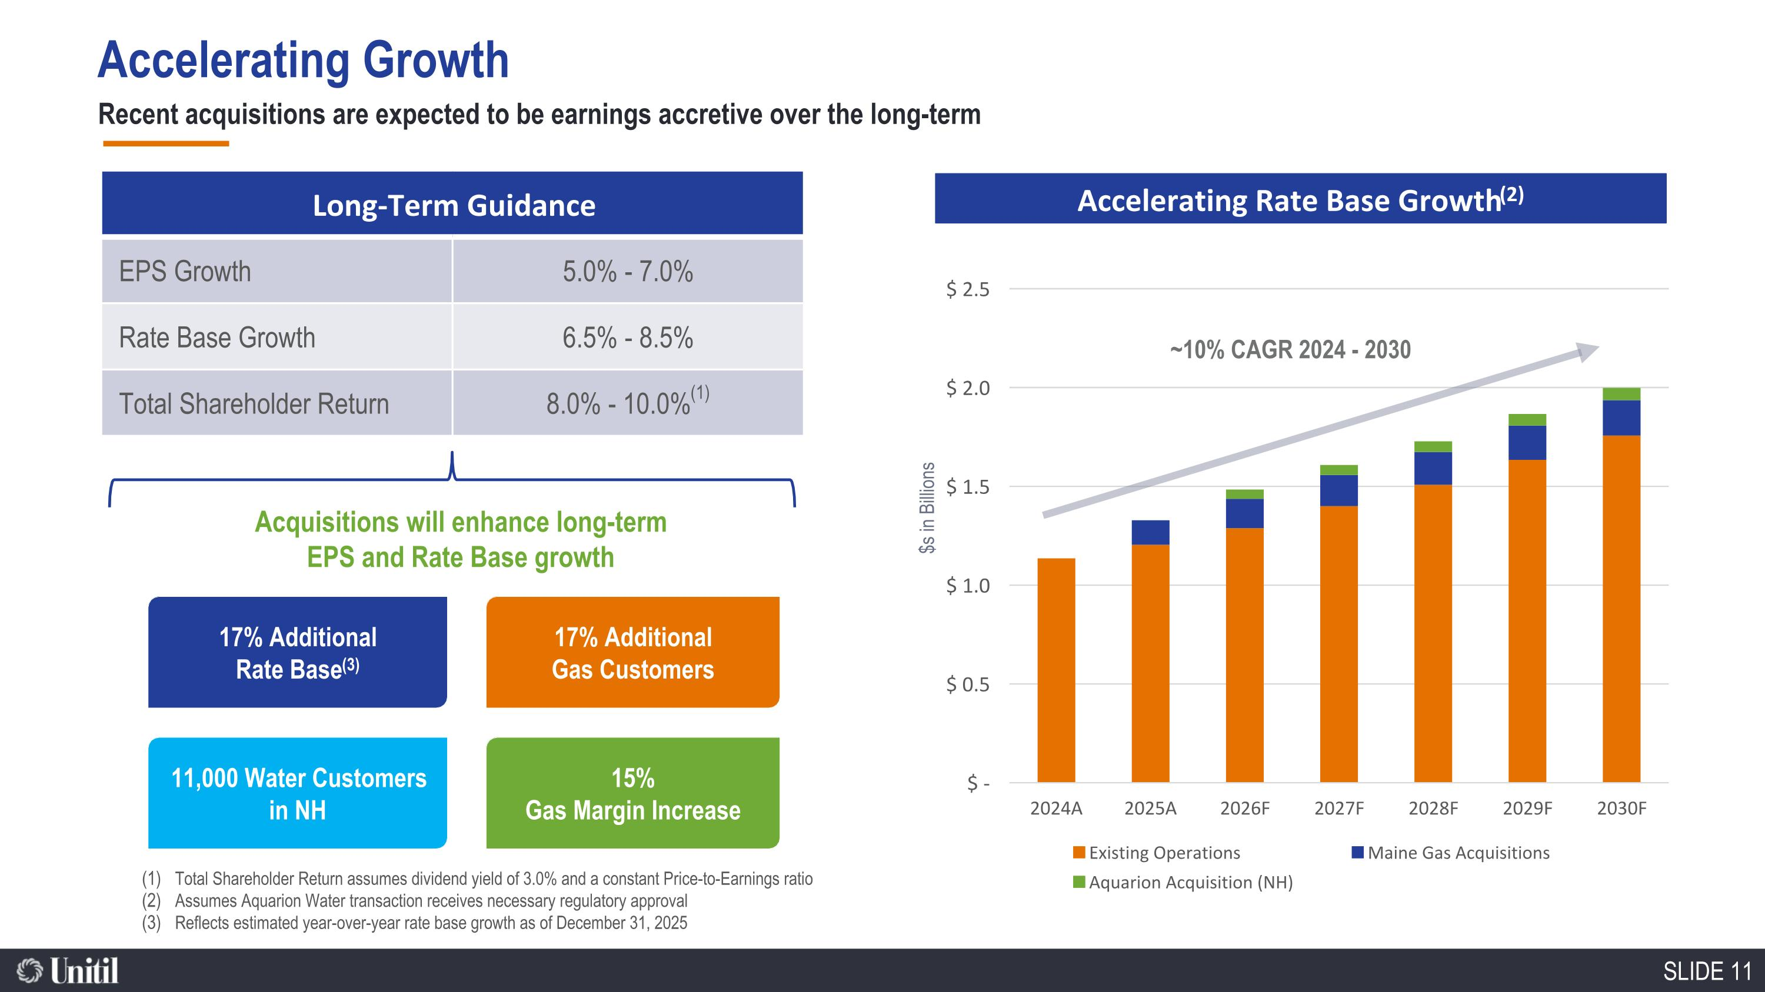
Accelerating Growth Recent acquisitions are expected to be earnings accretive over the long-term 17% Additional Rate Base(3) 15% Gas Margin Increase 17% Additional Gas Customers 11,000 Water Customers in NH Acquisitions will enhance long-term EPS and Rate Base growth Long-Term Guidance EPS Growth 5.0% - 7.0% Rate Base Growth 6.5% - 8.5% Total Shareholder Return 8.0% - 10.0%(1) Total Shareholder Return assumes dividend yield of 3.0% and a constant Price-to-Earnings ratio Assumes Aquarion Water transaction receives necessary regulatory approval Reflects estimated year-over-year rate base growth as of December 31, 2025 Accelerating Rate Base Growth(2) $s in Billions ~10% CAGR 2024 - 2030

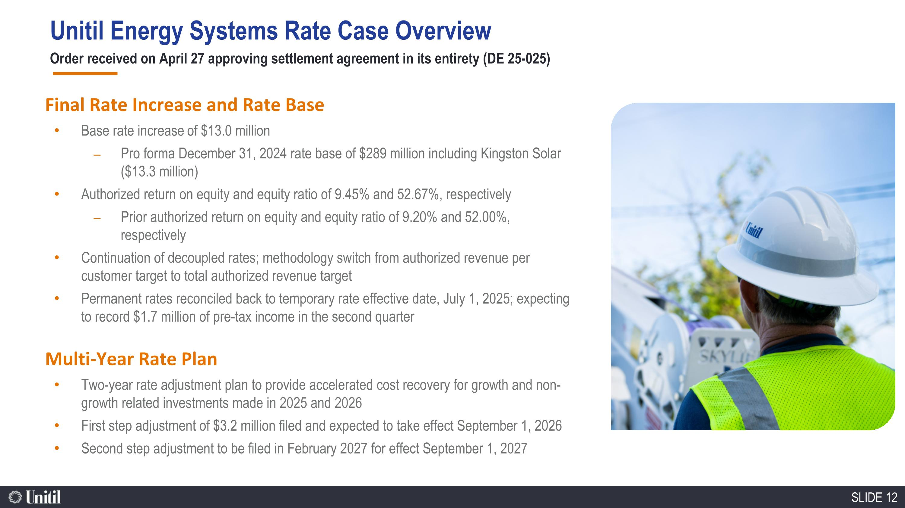
Order received on April 27 approving settlement agreement in its entirety (DE 25-025) Final Rate Increase and Rate Base Base rate increase of $13.0 million Pro forma December 31, 2024 rate base of $289 million including Kingston Solar ($13.3 million) Authorized return on equity and equity ratio of 9.45% and 52.67%, respectively Prior authorized return on equity and equity ratio of 9.20% and 52.00%, respectively Continuation of decoupled rates; methodology switch from authorized revenue per customer target to total authorized revenue target Permanent rates reconciled back to temporary rate effective date, July 1, 2025; expecting to record $1.7 million of pre-tax income in the second quarter Multi-Year Rate Plan Two-year rate adjustment plan to provide accelerated cost recovery for growth and non-growth related investments made in 2025 and 2026 First step adjustment of $3.2 million filed and expected to take effect September 1, 2026 Second step adjustment to be filed in February 2027 for effect September 1, 2027 Unitil Energy Systems Rate Case Overview

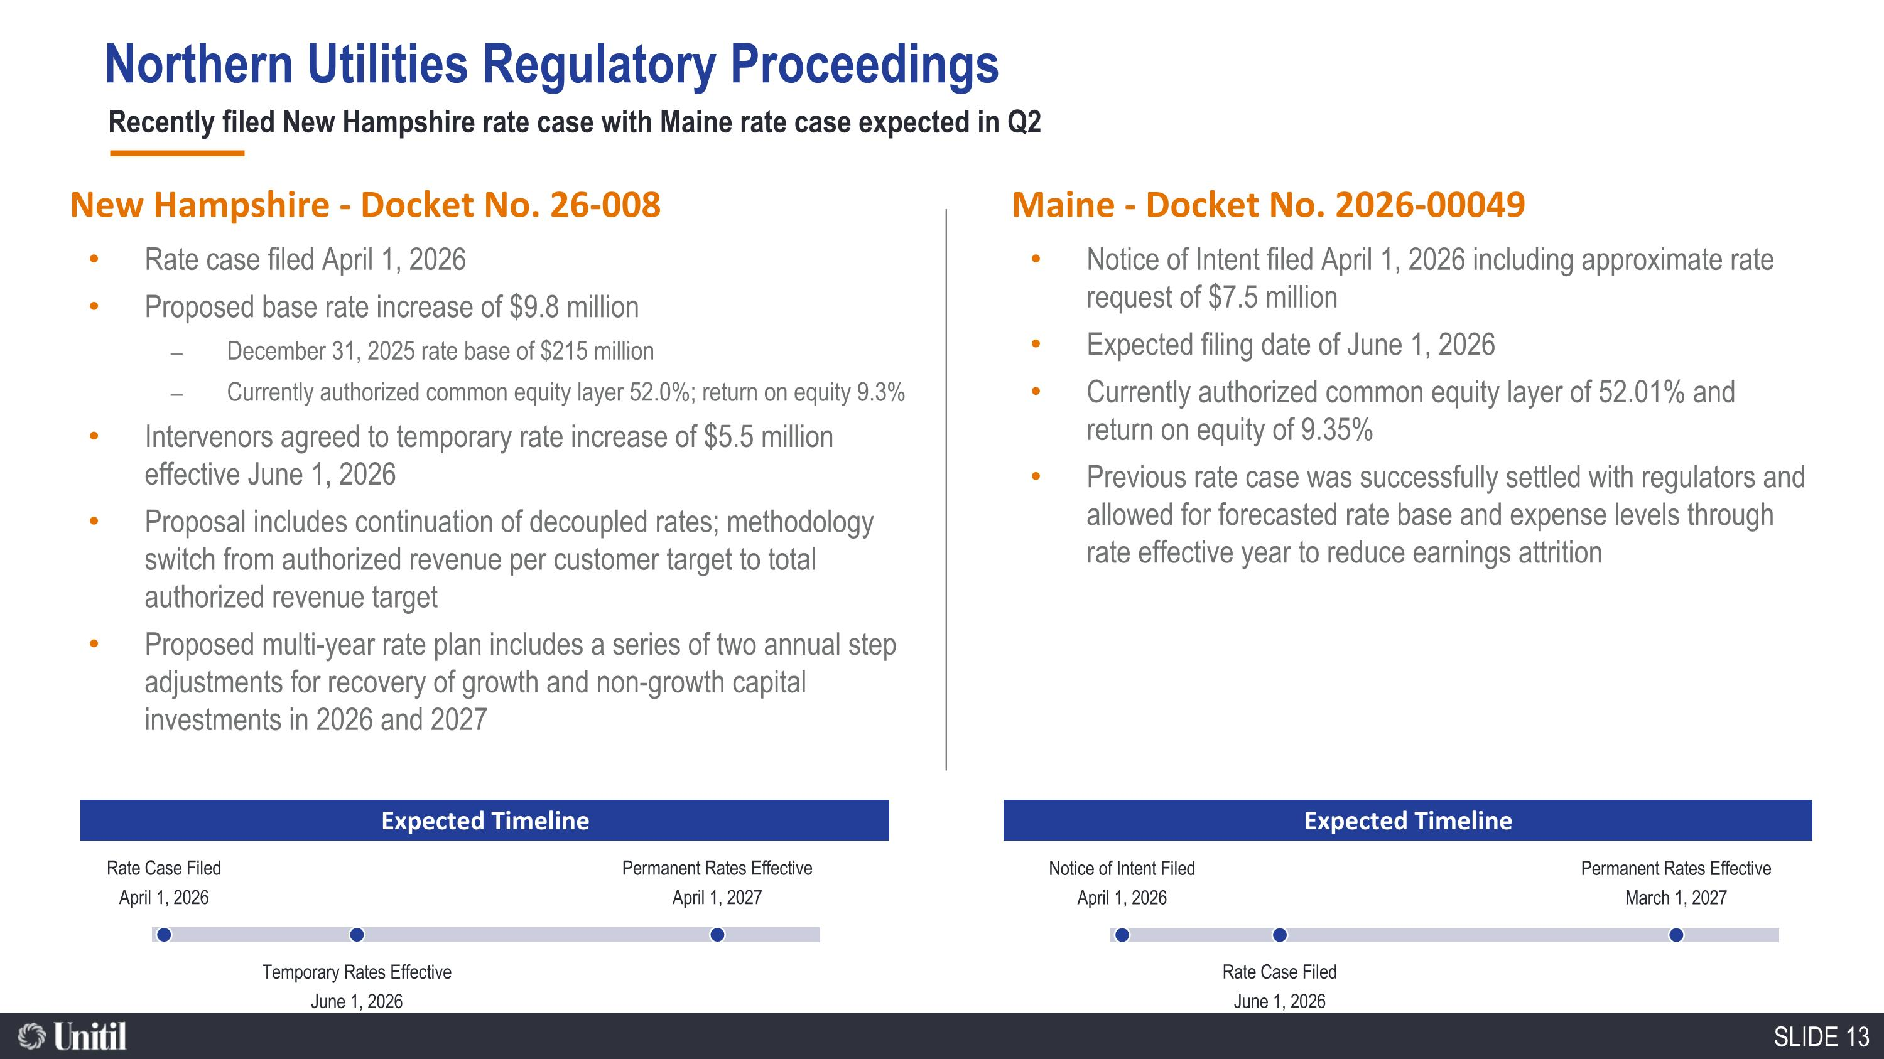
Recently filed New Hampshire rate case with Maine rate case expected in Q2 New Hampshire - Docket No. 26-008 Maine - Docket No. 2026-00049 Rate case filed April 1, 2026 Proposed base rate increase of $9.8 million December 31, 2025 rate base of $215 million Currently authorized common equity layer 52.0%; return on equity 9.3% Intervenors agreed to temporary rate increase of $5.5 million effective June 1, 2026 Proposal includes continuation of decoupled rates; methodology switch from authorized revenue per customer target to total authorized revenue target Proposed multi-year rate plan includes a series of two annual step adjustments for recovery of growth and non-growth capital investments in 2026 and 2027 Notice of Intent filed April 1, 2026 including approximate rate request of $7.5 million Expected filing date of June 1, 2026 Currently authorized common equity layer of 52.01% and return on equity of 9.35% Previous rate case was successfully settled with regulators and allowed for forecasted rate base and expense levels through rate effective year to reduce earnings attrition Rate Case Filed April 1, 2026 Temporary Rates Effective June 1, 2026 Permanent Rates Effective April 1, 2027 Expected Timeline Notice of Intent Filed April 1, 2026 Rate Case Filed June 1, 2026 Permanent Rates Effective March 1, 2027 Expected Timeline Northern Utilities Regulatory Proceedings

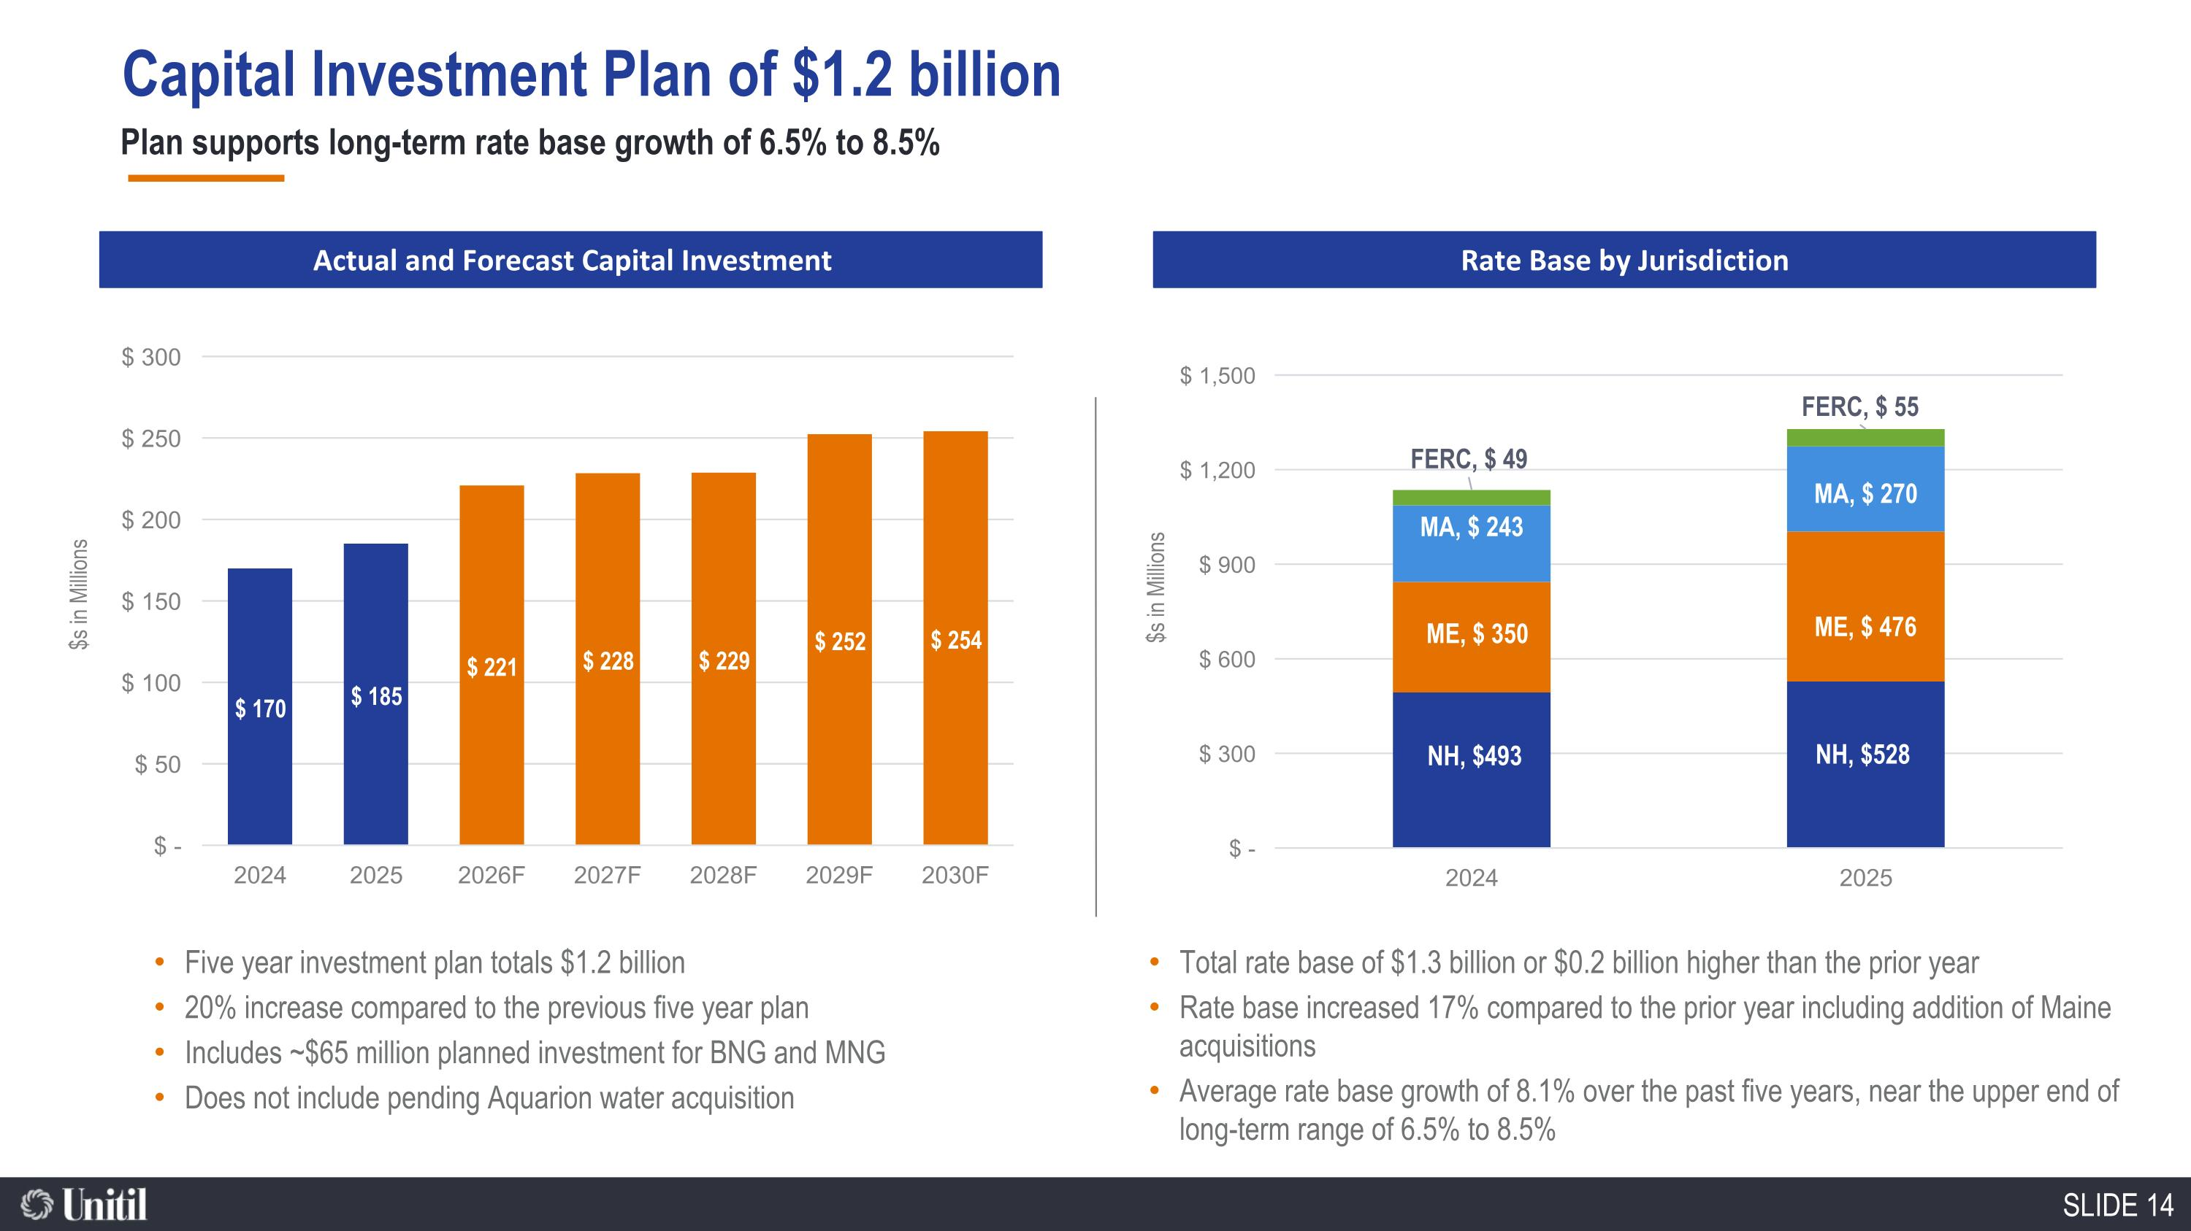
Capital Investment Plan of $1.2 billion Plan supports long-term rate base growth of 6.5% to 8.5% $s in Millions Actual and Forecast Capital Investment Rate Base by Jurisdiction $s in Millions Five year investment plan totals $1.2 billion 20% increase compared to the previous five year plan Includes ~$65 million planned investment for BNG and MNG Does not include pending Aquarion water acquisition Total rate base of $1.3 billion or $0.2 billion higher than the prior year Rate base increased 17% compared to the prior year including addition of Maine acquisitions Average rate base growth of 8.1% over the past five years, near the upper end of long-term range of 6.5% to 8.5%

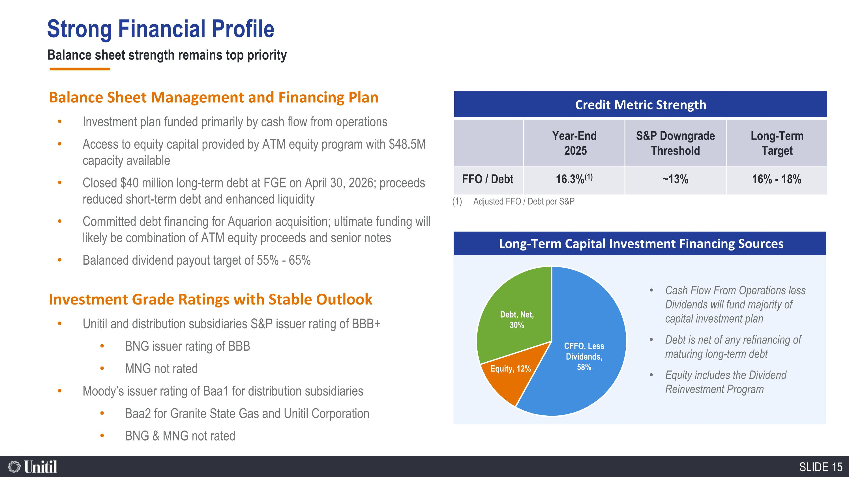
Balance sheet strength remains top priority Cash Flow From Operations less Dividends will fund majority of capital investment plan Debt is net of any refinancing of maturing long-term debt Equity includes the Dividend Reinvestment Program Long-Term Capital Investment Financing Sources Balance Sheet Management and Financing Plan Investment plan funded primarily by cash flow from operations Access to equity capital provided by ATM equity program with $48.5M capacity available Closed $40 million long-term debt at FGE on April 30, 2026; proceeds reduced short-term debt and enhanced liquidity Committed debt financing for Aquarion acquisition; ultimate funding will likely be combination of ATM equity proceeds and senior notes Balanced dividend payout target of 55% - 65% Investment Grade Ratings with Stable Outlook Unitil and distribution subsidiaries S&P issuer rating of BBB+ BNG issuer rating of BBB MNG not rated Moody’s issuer rating of Baa1 for distribution subsidiaries Baa2 for Granite State Gas and Unitil Corporation BNG & MNG not rated Credit Metric Strength Year-End 2025 S&P Downgrade Threshold Long-Term Target FFO / Debt 16.3%(1) ~13% 16% - 18% Adjusted FFO / Debt per S&P Strong Financial Profile

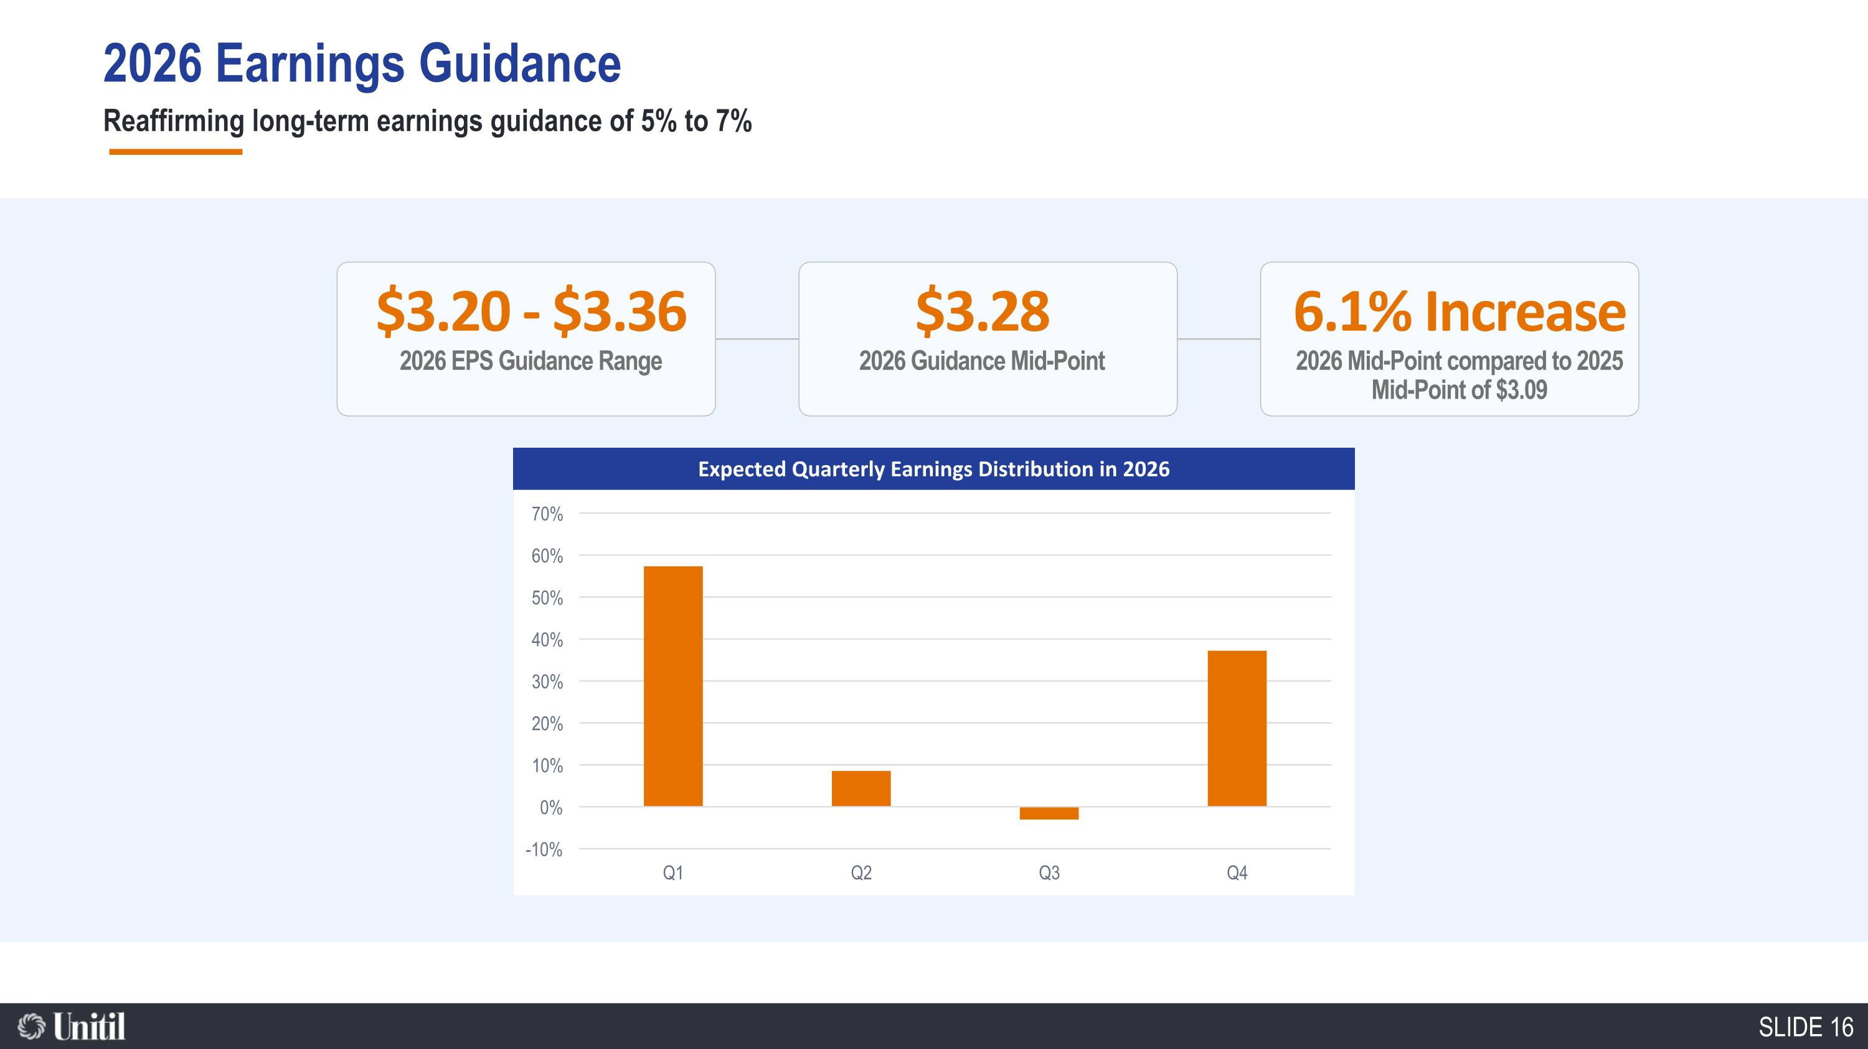
Reaffirming long-term earnings guidance of 5% to 7% Expected Quarterly Earnings Distribution in 2026 $3.20 - $3.36 2026 EPS Guidance Range $3.28 2026 Guidance Mid-Point 6.1% Increase 2026 Mid-Point compared to 2025 Mid-Point of $3.09 2026 Earnings Guidance

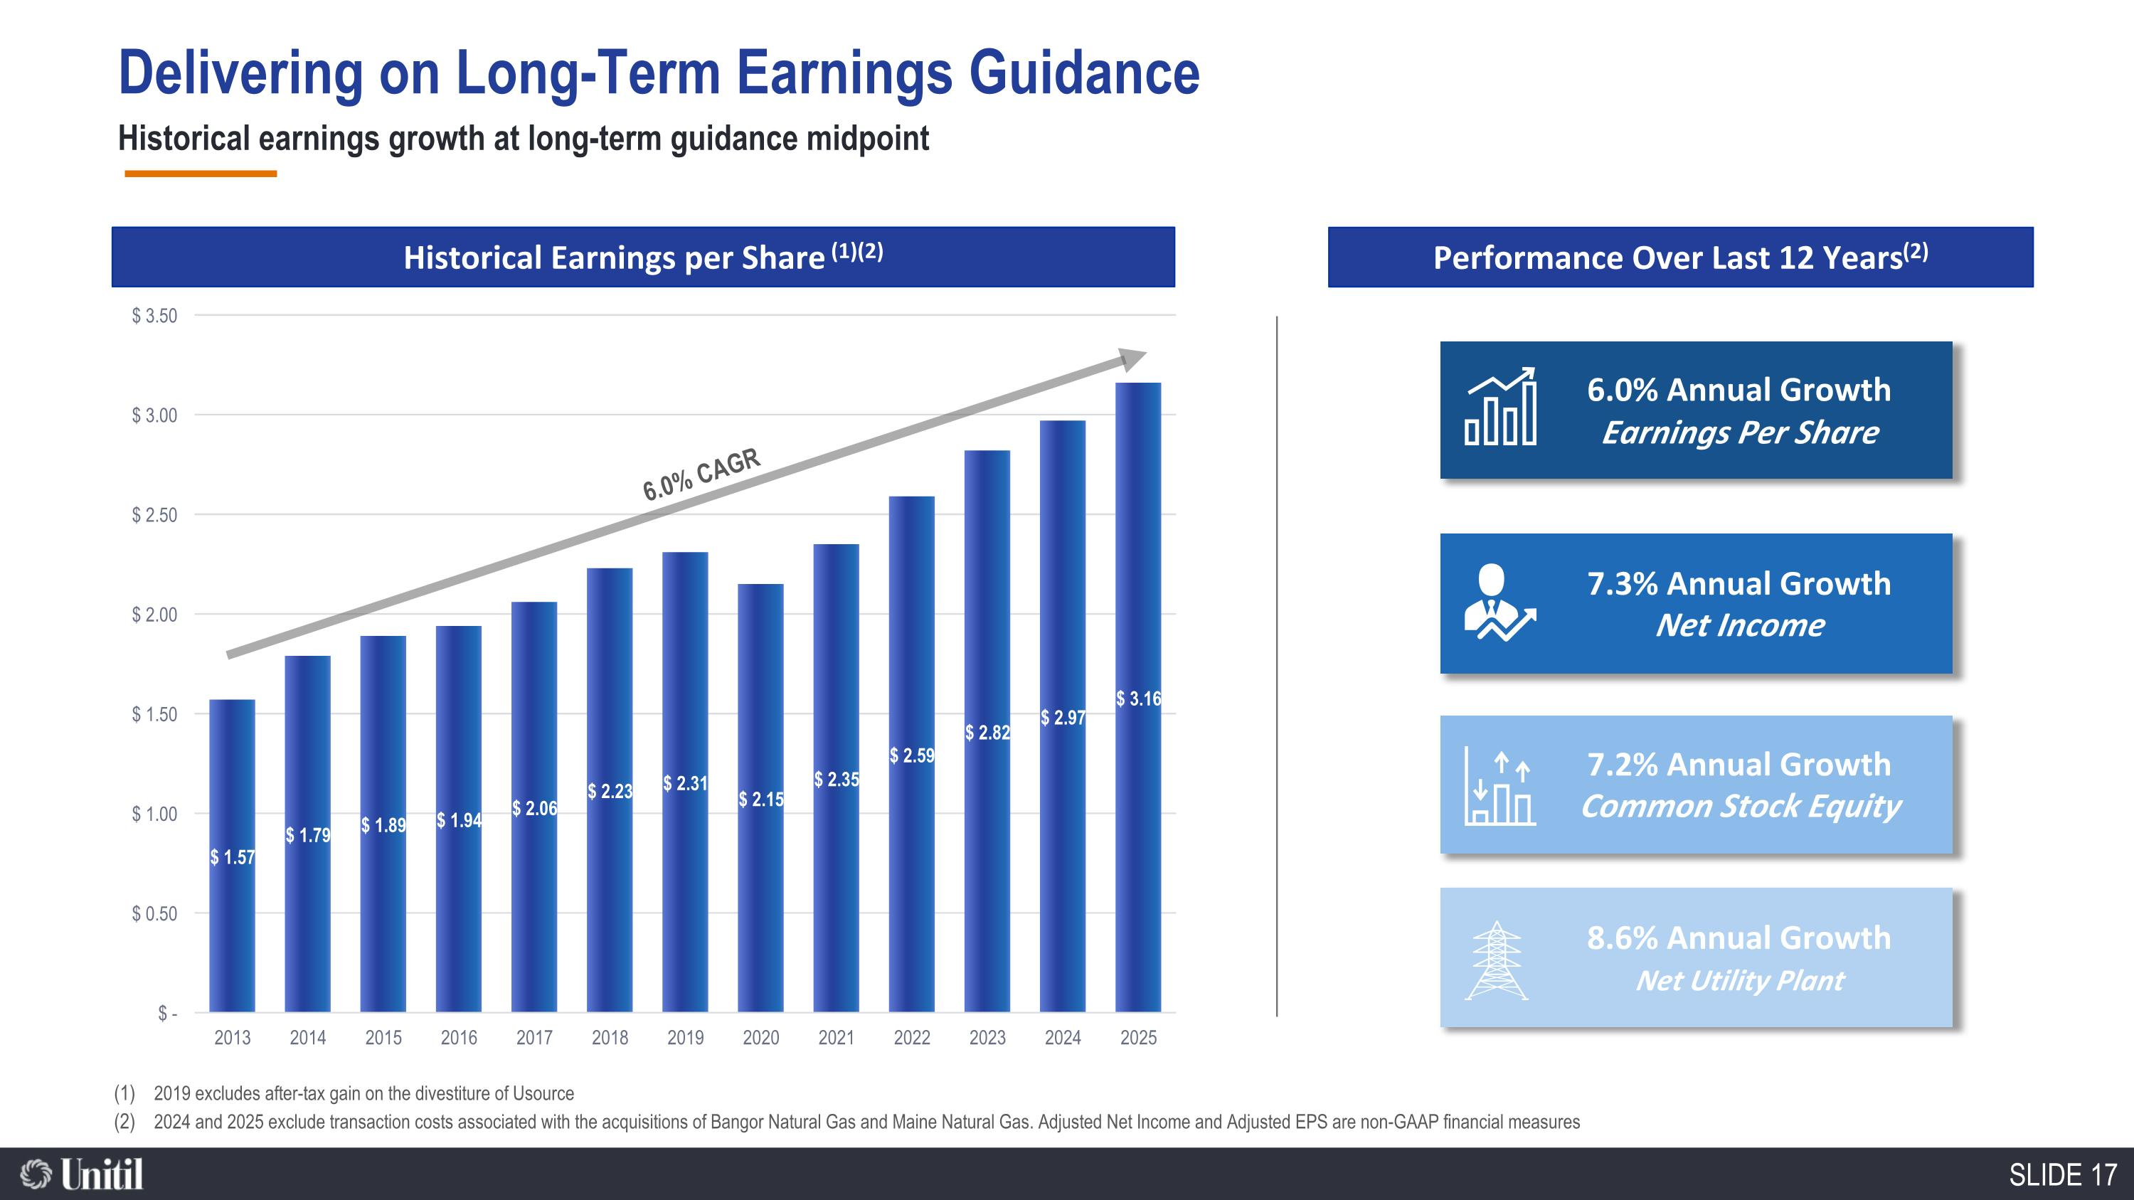
7.3% Annual Growth Net Income Delivering on Long-Term Earnings Guidance Historical earnings growth at long-term guidance midpoint Historical Earnings per Share (1)(2) 7.2% Annual Growth Common Stock Equity 6.0% Annual Growth Earnings Per Share 6.0% CAGR 8.6% Annual Growth Net Utility Plant Performance Over Last 12 Years (2) 2019 excludes after-tax gain on the divestiture of Usource 2024 and 2025 exclude transaction costs associated with the acquisitions of Bangor Natural Gas and Maine Natural Gas. Adjusted Net Income and Adjusted EPS are non-GAAP financial measures

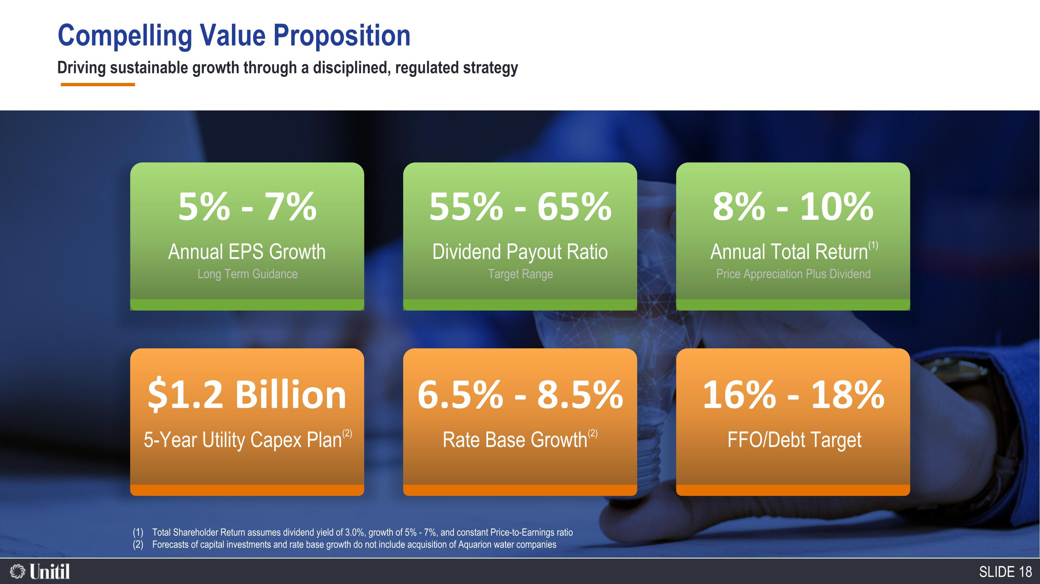
Compelling Value Proposition 5% - 7% Annual EPS Growth Long Term Guidance $1.2 Billion 5-Year Utility Capex Plan(2) 55% - 65% Dividend Payout Ratio Target Range 6.5% - 8.5% Rate Base Growth(2) 8% - 10% Annual Total Return(1) Price Appreciation Plus Dividend 16% - 18% FFO/Debt Target Total Shareholder Return assumes dividend yield of 3.0%, growth of 5% - 7%, and constant Price-to-Earnings ratio Forecasts of capital investments and rate base growth do not include acquisition of Aquarion water companies Driving sustainable growth through a disciplined, regulated strategy

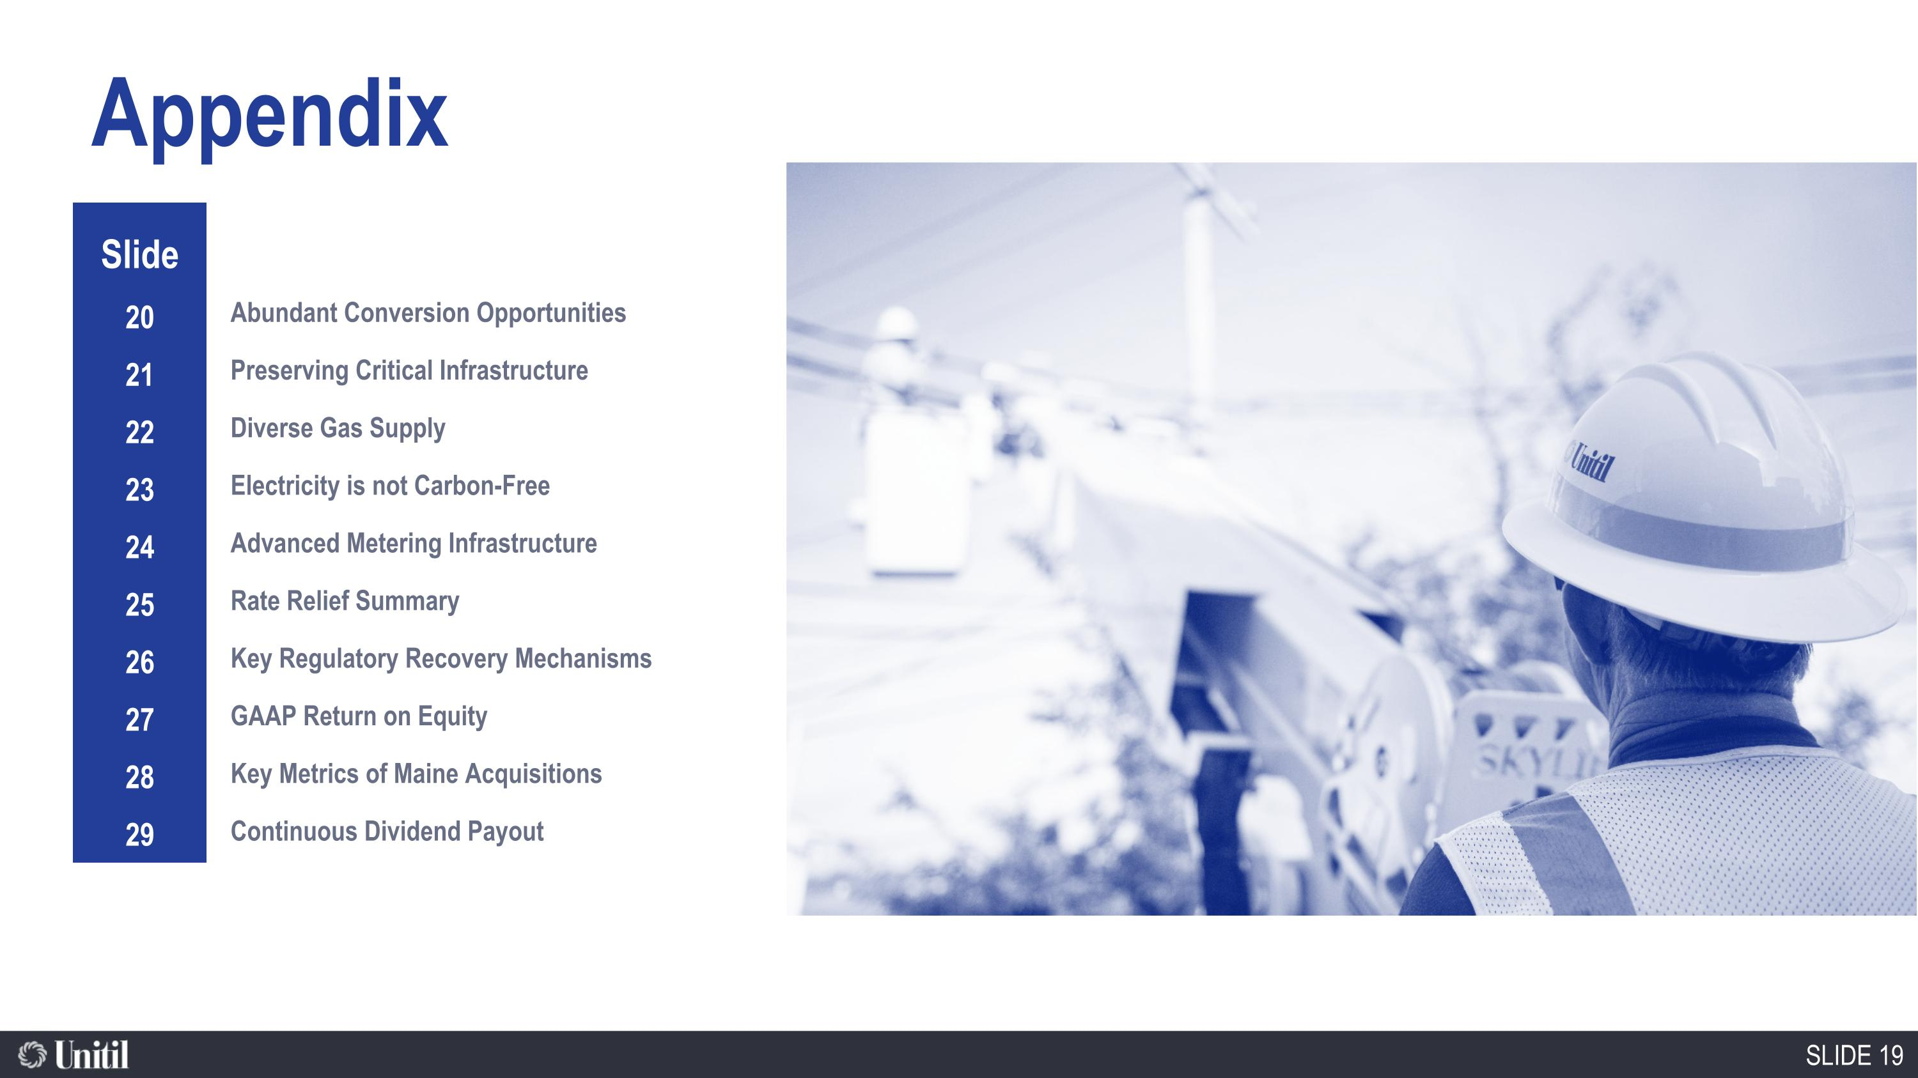
86,600 Natural Gas Customers Appendix Slide 20 21 22 23 24 25 26 27 28 29 Abundant Conversion Opportunities Preserving Critical Infrastructure Diverse Gas Supply Electricity is not Carbon-Free Advanced Metering Infrastructure Rate Relief Summary Key Regulatory Recovery Mechanisms GAAP Return on Equity Key Metrics of Maine Acquisitions Continuous Dividend Payout

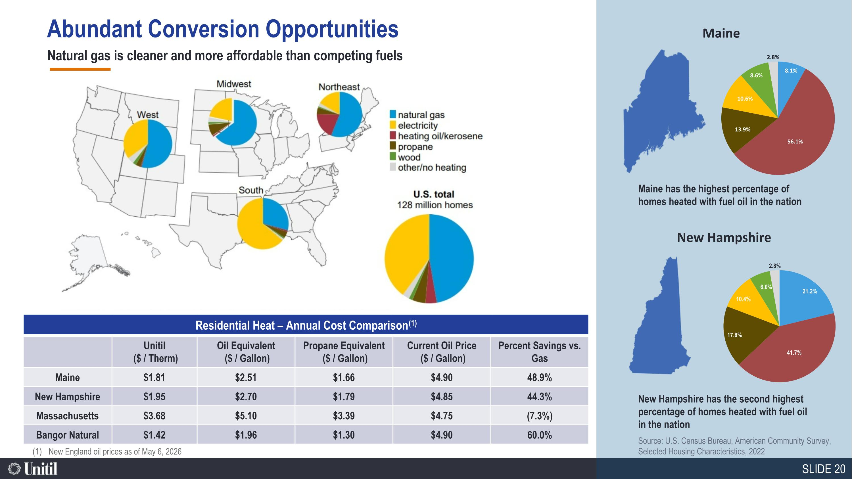
Maine New Hampshire Maine has the highest percentage of homes heated with fuel oil in the nation New Hampshire has the second highest percentage of homes heated with fuel oil in the nation Natural gas is cleaner and more affordable than competing fuels Source: U.S. Census Bureau, American Community Survey, Selected Housing Characteristics, 2022 New England oil prices as of May 6, 2026 Abundant Conversion Opportunities Residential Heat – Annual Cost Comparison(1) Unitil ($ / Therm) Oil Equivalent ($ / Gallon) Propane Equivalent ($ / Gallon) Current Oil Price ($ / Gallon) Percent Savings vs. Gas Maine $1.81 $2.51 $1.66 $4.90 48.9% New Hampshire $1.95 $2.70 $1.79 $4.85 44.3% Massachusetts $3.68 $5.10 $3.39 $4.75 (7.3%) Bangor Natural $1.42 $1.96 $1.30 $4.90 60.0%

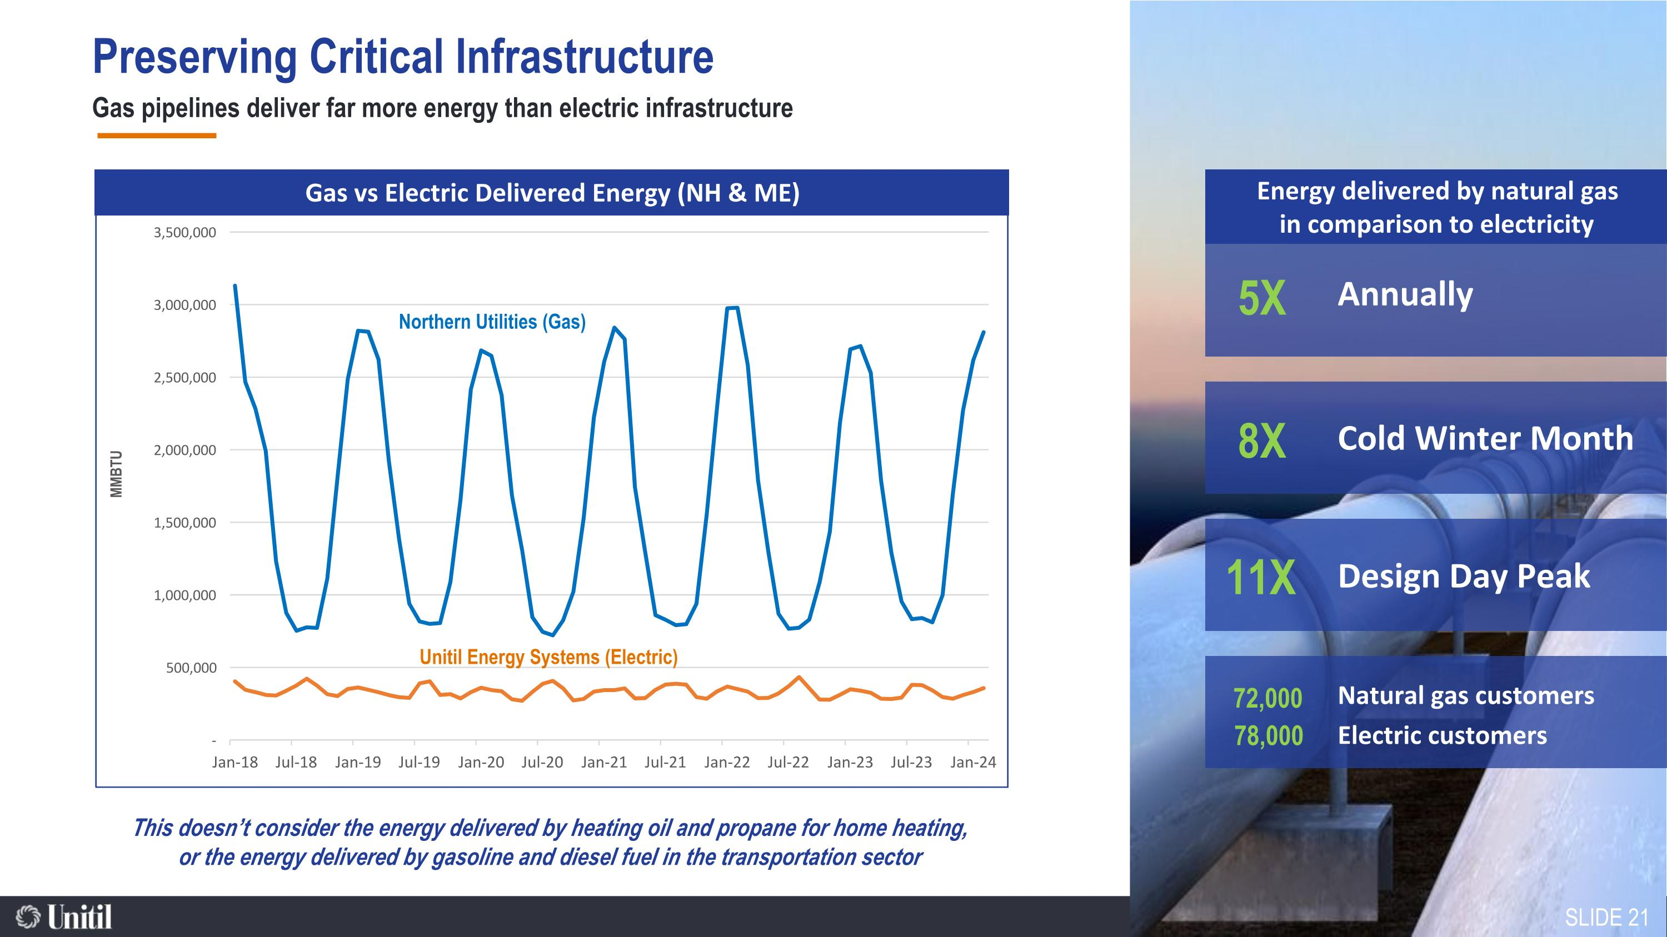
Gas pipelines deliver far more energy than electric infrastructure Nuclear Natural Gas Hydro Renewables Solar Wind Annually 8X 5X 11X 72,000 Cold Winter Month Design Day Peak Natural gas customers Electric customers Energy delivered by natural gas in comparison to electricity Gas vs Electric Delivered Energy (NH & ME) 78,000 This doesn’t consider the energy delivered by heating oil and propane for home heating, or the energy delivered by gasoline and diesel fuel in the transportation sector Northern Utilities (Gas) Unitil Energy Systems (Electric) Preserving Critical Infrastructure SLIDE 21

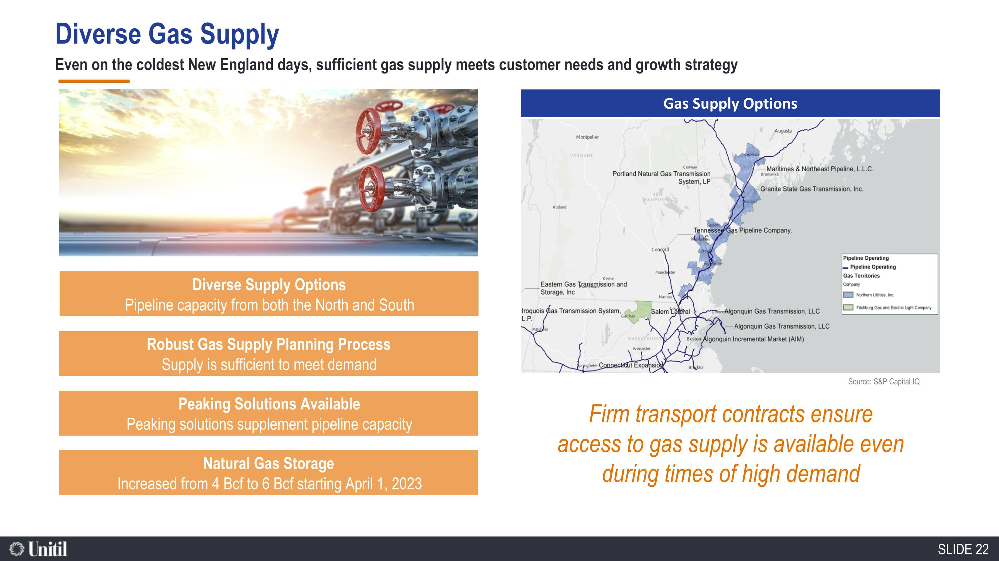
Even on the coldest New England days, sufficient gas supply meets customer needs and growth strategy Gas Supply Options Source: S&P Capital IQ Peaking Solutions Available Peaking solutions supplement pipeline capacity Robust Gas Supply Planning Process Supply is sufficient to meet demand Diverse Supply Options Pipeline capacity from both the North and South Natural Gas Storage Increased from 4 Bcf to 6 Bcf starting April 1, 2023 SLIDE 22 Firm transport contracts ensure access to gas supply is available even during times of high demand Diverse Gas Supply

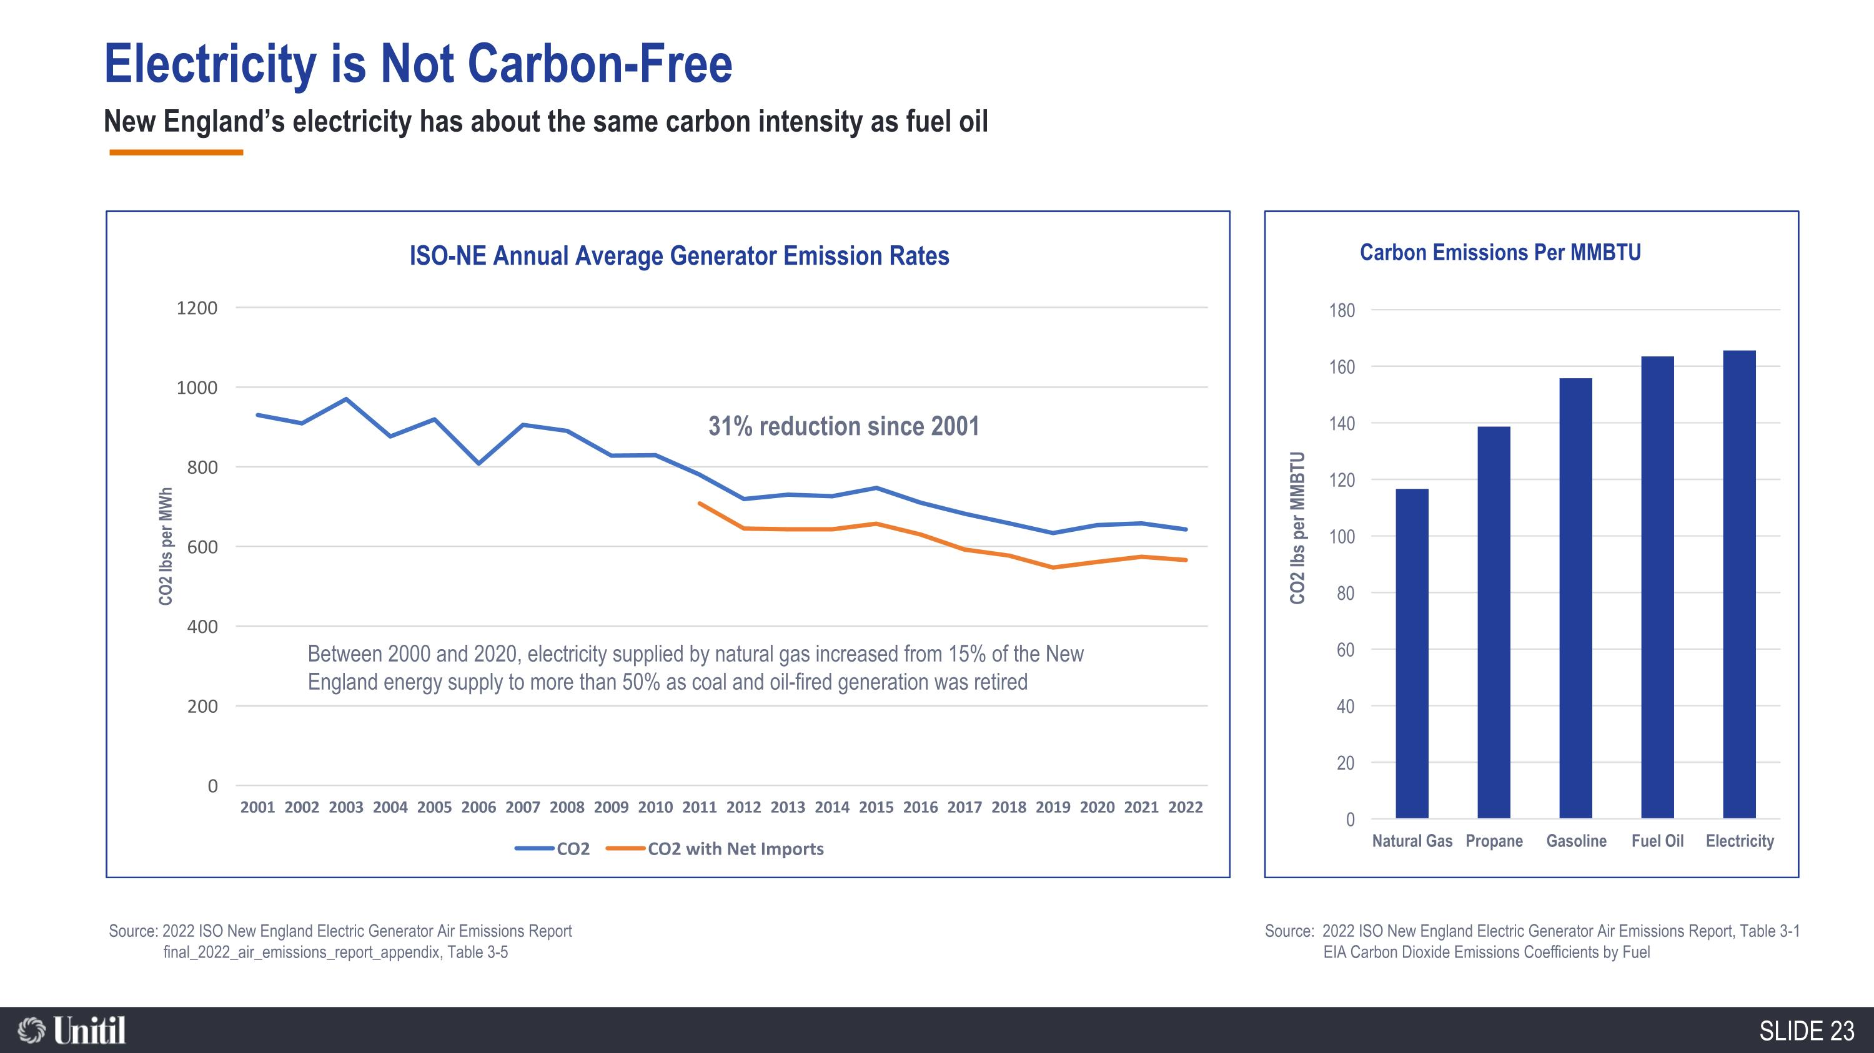
New England’s electricity has about the same carbon intensity as fuel oil Wind Wood Nuclear Hydro Natural Gas Renewables Wind Solar Wood Refuse Source: 2022 ISO New England Electric Generator Air Emissions Report, Table 3-1 EIA Carbon Dioxide Emissions Coefficients by Fuel Source: 2022 ISO New England Electric Generator Air Emissions Report final_2022_air_emissions_report_appendix, Table 3-5 31% reduction since 2001 Between 2000 and 2020, electricity supplied by natural gas increased from 15% of the New England energy supply to more than 50% as coal and oil-fired generation was retired SLIDE 23 Electricity is Not Carbon-Free

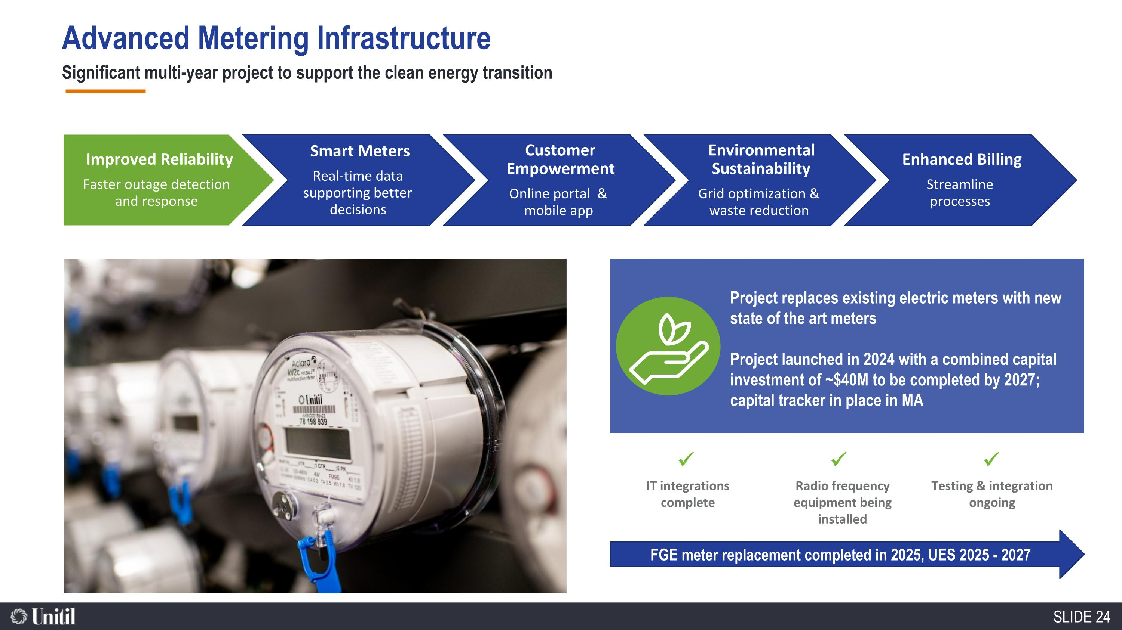
Significant multi-year project to support the clean energy transition Environmental Sustainability Grid optimization & waste reduction Customer Empowerment Online portal & mobile app Improved Reliability Faster outage detection and response Enhanced Billing Streamline processes Smart Meters Real-time data supporting better decisions Project replaces existing electric meters with new state of the art meters Project launched in 2024 with a combined capital investment of ~$40M to be completed by 2027; capital tracker in place in MA Testing & integration ongoing Radio frequency equipment being installed IT integrations complete ✓ ✓ FGE meter replacement completed in 2025, UES 2025 - 2027 ✓ SLIDE 24 Advanced Metering Infrastructure

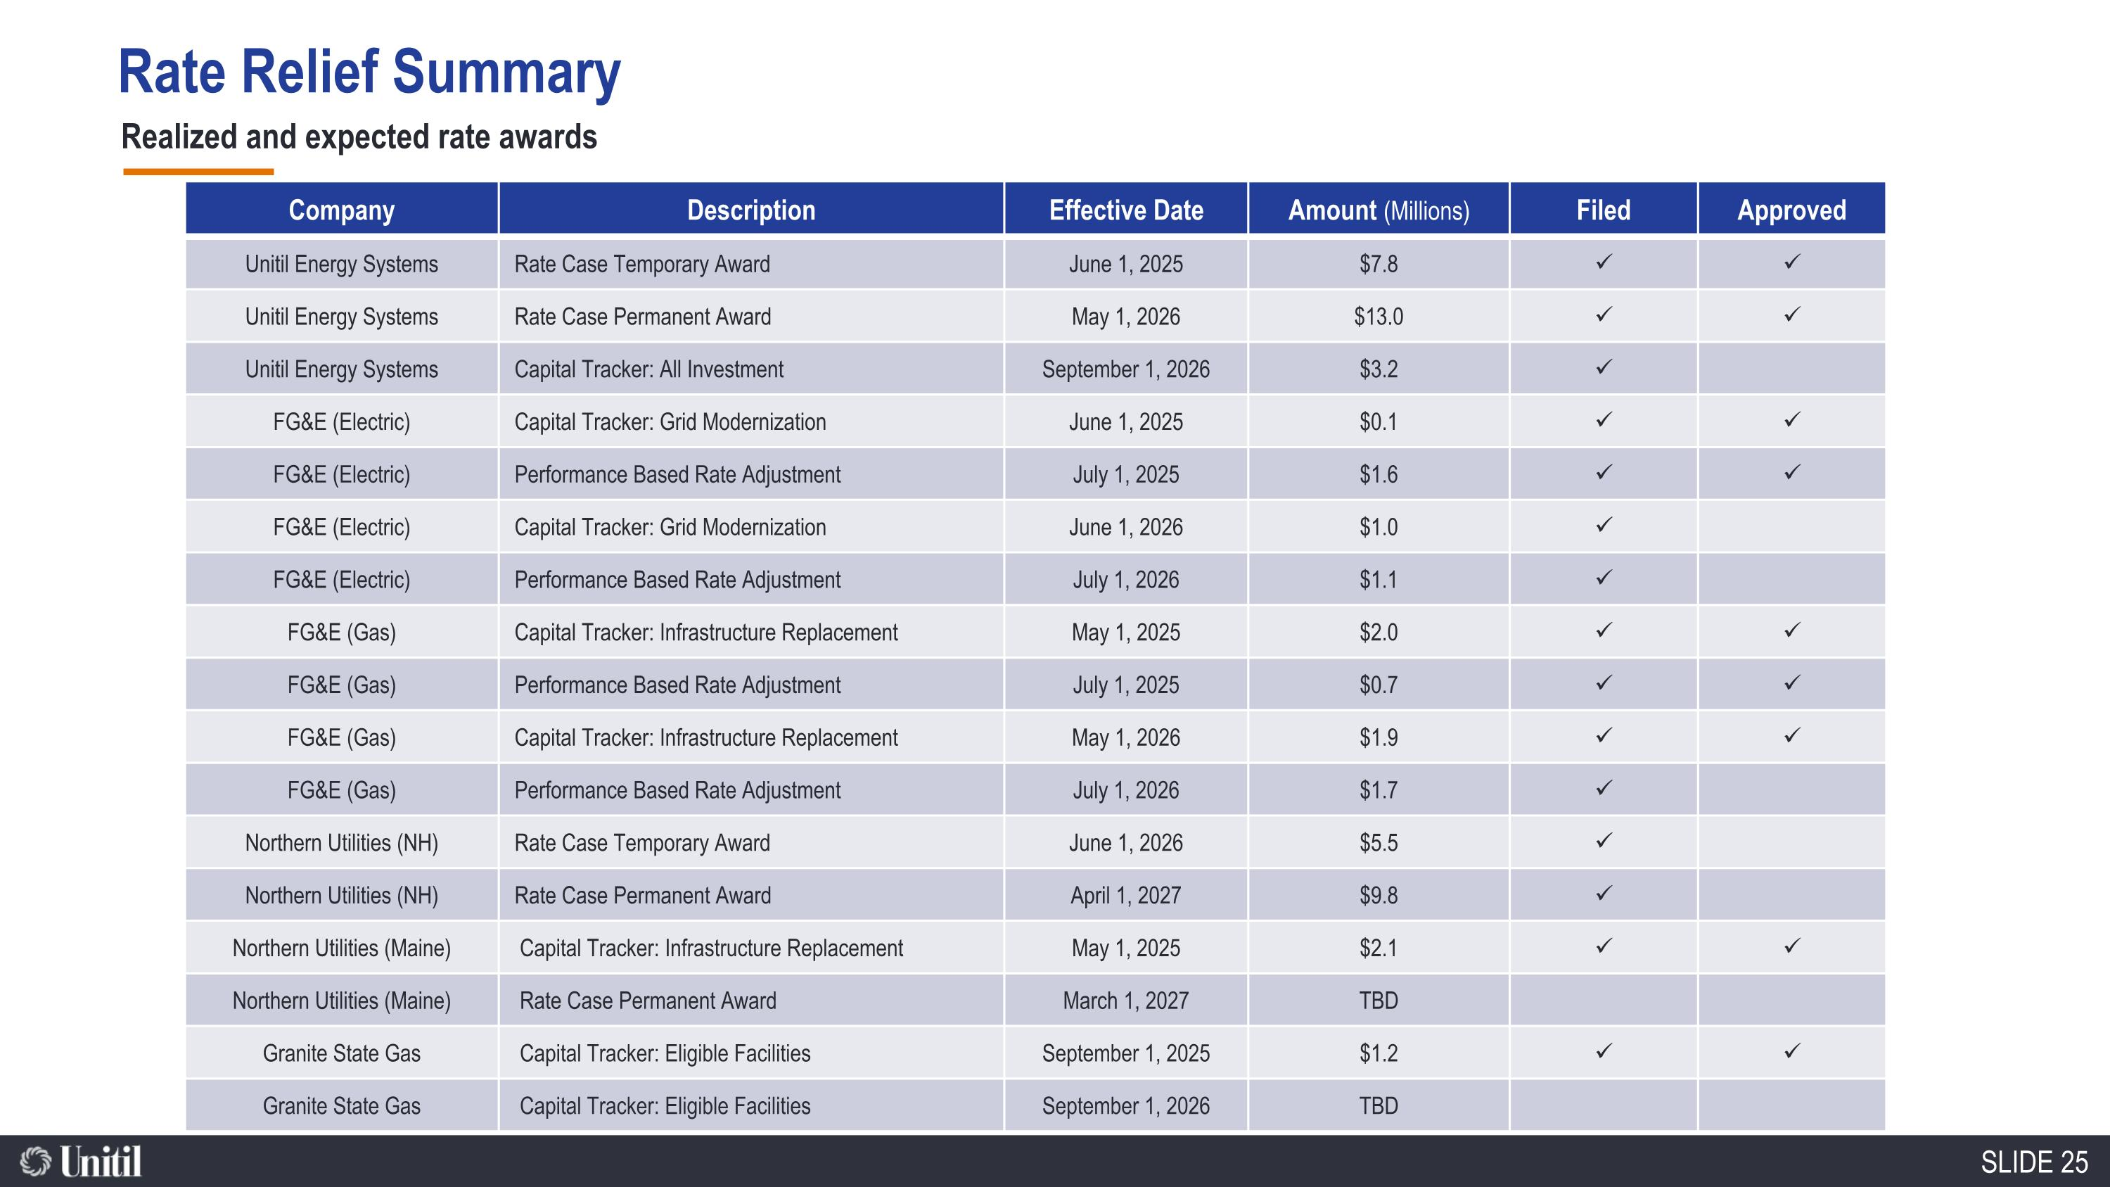
Rate Relief Summary Realized and expected rate awards Company Description Effective Date Amount (Millions) Filed Approved Unitil Energy Systems Rate Case Temporary Award June 1, 2025 $7.8 ✓ ✓ Unitil Energy Systems Rate Case Permanent Award May 1, 2026 $13.0 ✓ ✓ Unitil Energy Systems Capital Tracker: All Investment September 1, 2026 $3.2 ✓ FG&E (Electric) Capital Tracker: Grid Modernization June 1, 2025 $0.1 ✓ ✓ FG&E (Electric) Performance Based Rate Adjustment July 1, 2025 $1.6 ✓ ✓ FG&E (Electric) Capital Tracker: Grid Modernization June 1, 2026 $1.0 ✓ FG&E (Electric) Performance Based Rate Adjustment July 1, 2026 $1.1 ✓ FG&E (Gas) Capital Tracker: Infrastructure Replacement May 1, 2025 $2.0 ✓ ✓ FG&E (Gas) Performance Based Rate Adjustment July 1, 2025 $0.7 ✓ ✓ FG&E (Gas) Capital Tracker: Infrastructure Replacement May 1, 2026 $1.9 ✓ ✓ FG&E (Gas) Performance Based Rate Adjustment July 1, 2026 $1.7 ✓ Northern Utilities (NH) Rate Case Temporary Award June 1, 2026 $5.5 ✓ Northern Utilities (NH) Rate Case Permanent Award April 1, 2027 $9.8 ✓ Northern Utilities (Maine) Capital Tracker: Infrastructure Replacement May 1, 2025 $2.1 ✓ ✓ Northern Utilities (Maine) Rate Case Permanent Award March 1, 2027 TBD Granite State Gas Capital Tracker: Eligible Facilities September 1, 2025 $1.2 ✓ ✓ Granite State Gas Capital Tracker: Eligible Facilities September 1, 2026 TBD SLIDE 25

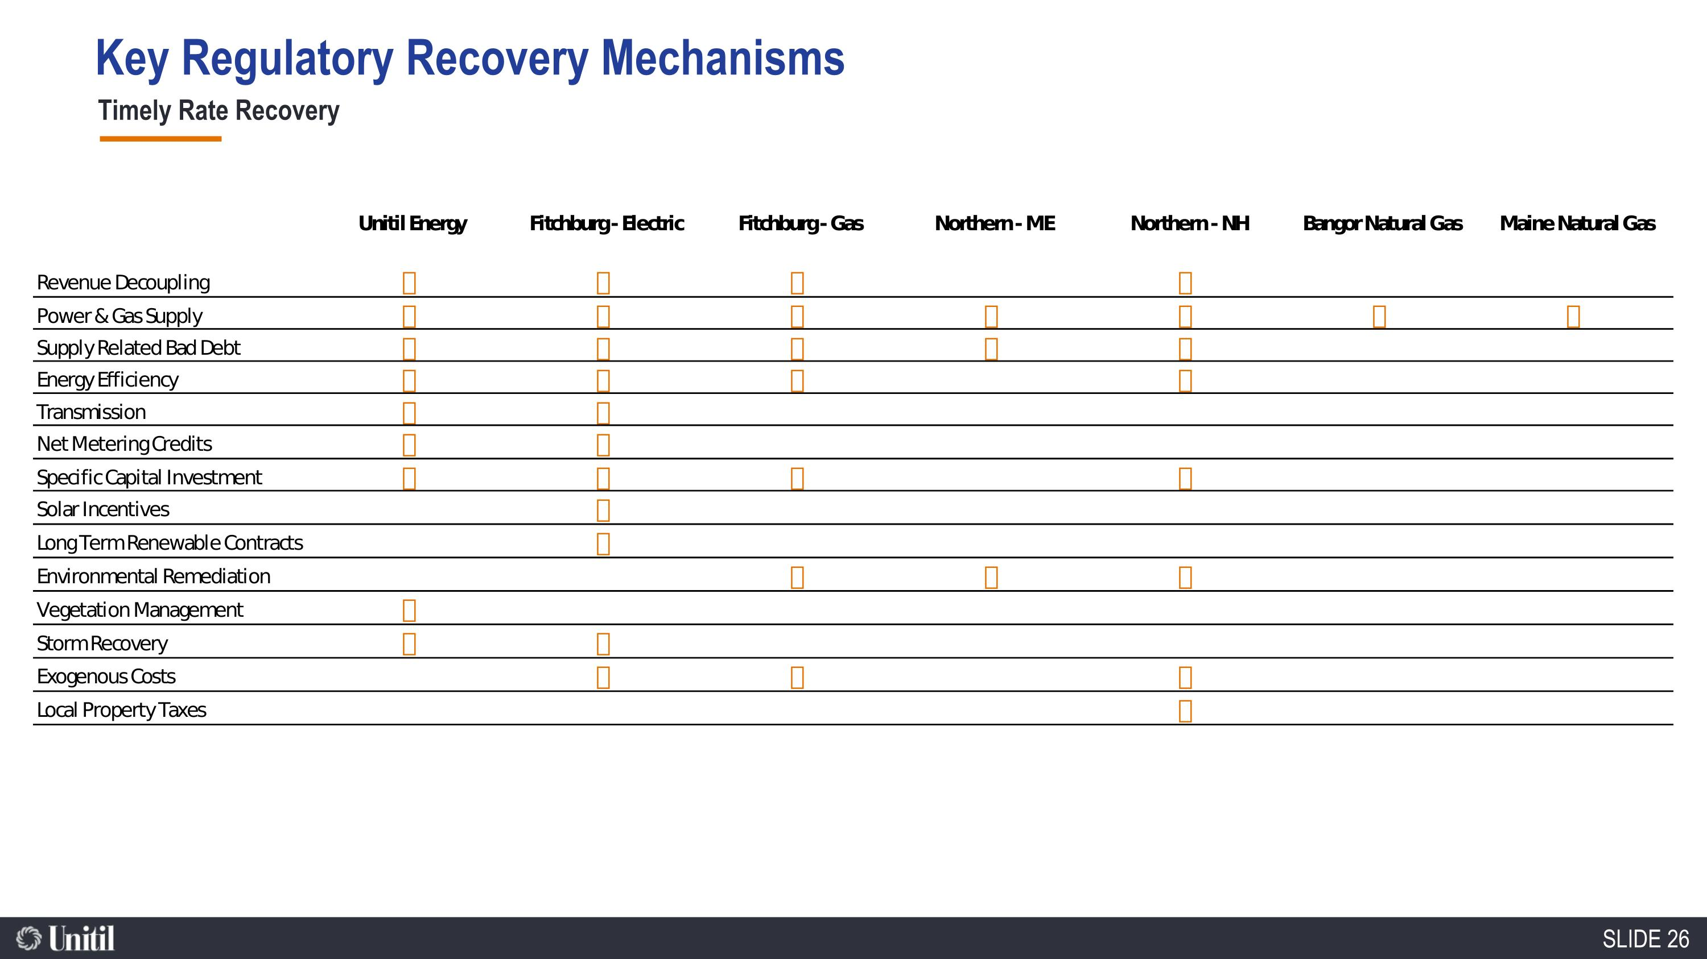
86,600 Natural Gas Customers Timely Rate Recovery Key Regulatory Recovery Mechanisms SLIDE 26

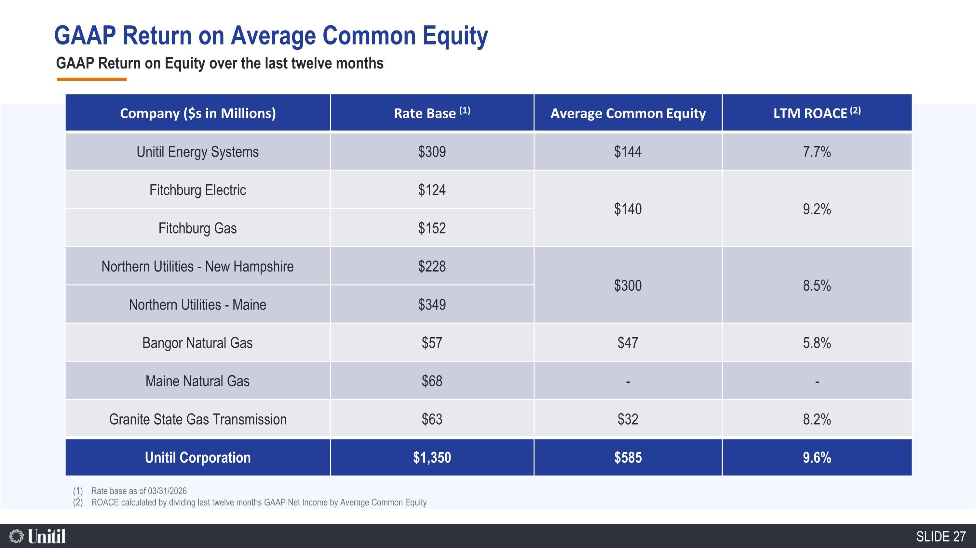
GAAP Return on Equity over the last twelve months Rate base as of 03/31/2026 ROACE calculated by dividing last twelve months GAAP Net Income by Average Common Equity Company ($s in Millions) Rate Base (1) Average Common Equity LTM ROACE (2) Unitil Energy Systems $309 $144 7.7% Fitchburg Electric $124 $140 9.2% Fitchburg Gas $152 Northern Utilities - New Hampshire $228 $300 8.5% Northern Utilities - Maine $349 Bangor Natural Gas $57 $47 5.8% Maine Natural Gas $68 - - Granite State Gas Transmission $63 $32 8.2% Unitil Corporation $1,350 $585 9.6% GAAP Return on Average Common Equity SLIDE 27

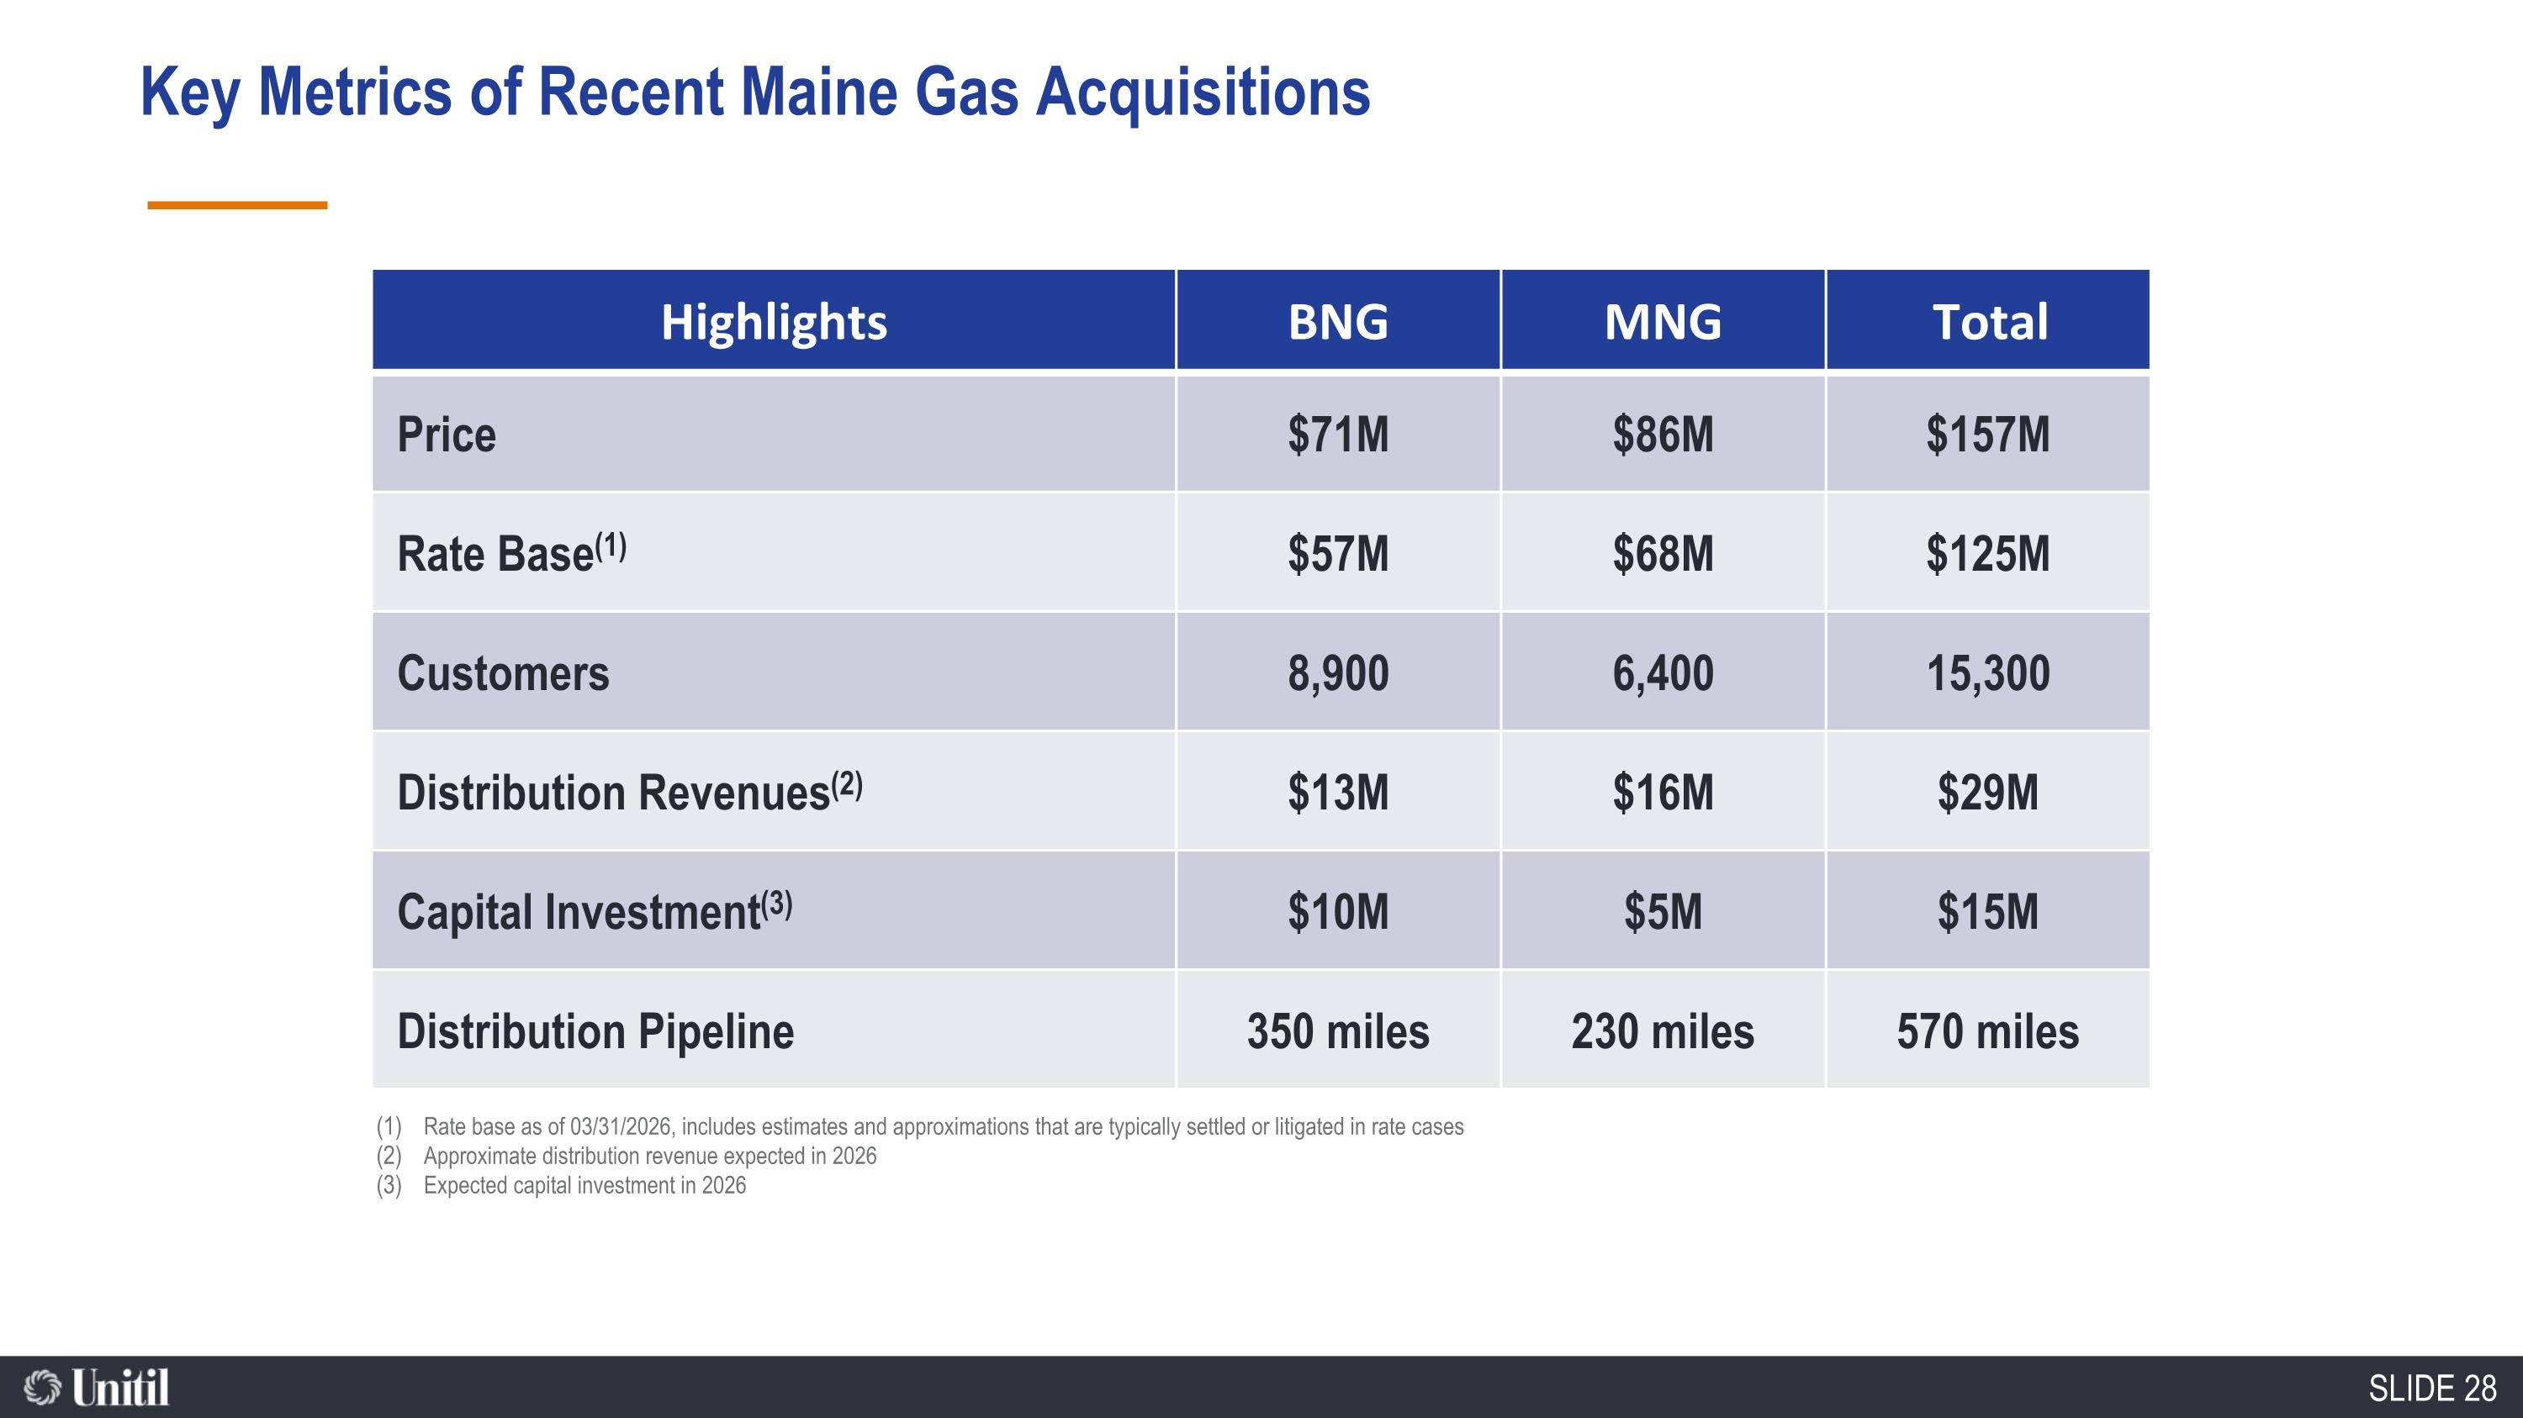
86,600 Natural Gas Customers Highlights BNG MNG Total Price $71M $86M $157M Rate Base(1) $57M $68M $125M Customers 8,900 6,400 15,300 Distribution Revenues(2) $13M $16M $29M Capital Investment(3) $10M $5M $15M Distribution Pipeline 350 miles 230 miles 570 miles Rate base as of 03/31/2026, includes estimates and approximations that are typically settled or litigated in rate cases Approximate distribution revenue expected in 2026 Expected capital investment in 2026 Key Metrics of Recent Maine Gas Acquisitions SLIDE 28

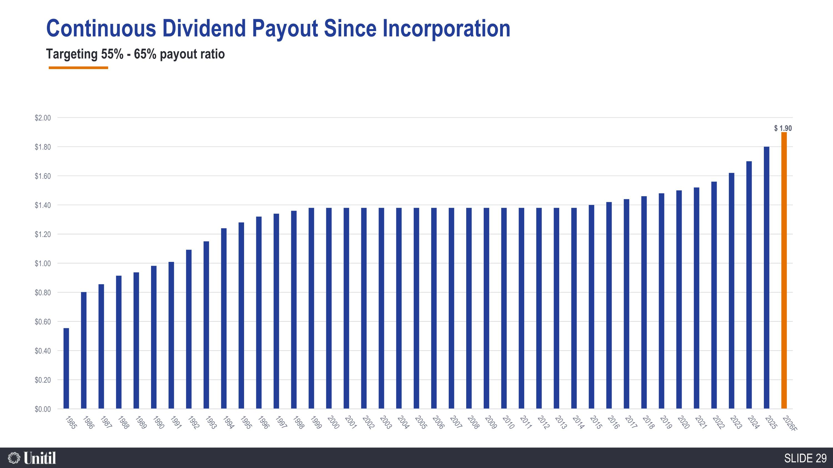
86,600 Natural Gas Customers Targeting 55% - 65% payout ratio Continuous Dividend Payout Since Incorporation

